  - CASE REPORT

Primary dural-based MALT lymphoma mimicking falx meningioma: a case report
O. Andrushkevich1,2*, E. Filimonova1,2, A. Kalinovsky1,2, J. Rzaev1,2,3

- Federal Center of Neurosurgery Novosibirsk, Nemirovich-Danchenko Str. 132/1, Novosibirsk 630087, Russia
- Novosibirsk State Medical University, Krasny Prospect St. 52, Novosibirsk 630091, Russia
- Department of Neuroscience, Institute of Medicine and Psychology, Novosibirsk State University, Pirogov Str. 1, Novosibirsk 630090, Russia

Abstract
Introduction
Primary dural lymphoma (PDL) is very rare and often misdiagnosed as meningioma based on neuroimaging characteristics.
Case report
A 36-year-old woman presented with headache, behaviour changes and ataxia. She had no history of oncology or immunodeficiency. Magnetic resonance imaging showed a solitary mass lesion in the anterior and middle thirds of the falx cerebri with bilateral growth and a moderate mass effect, which was interpreted as a falx meningioma. Gross total resection of the lesion involving the dura mater of the falx cerebri was performed by bilateral parasagittal craniotomy. Surprisingly, histological examination showed no meningothelial components. Instead, there was diffuse lymphocytic and plasma cell infiltration. Immunohistochemistry was positive for B-cell antigens. The final histopathological diagnosis was primary dural mucosa-associated lymphoid tissue lymphoma. Systemic screening examination was then performed and did not reveal additional tumor foci or lymphadenopathy. Follow-up brain MRI at 3 months did not reveal tumor progression. Neither chemotherapy nor radiotherapy were given, and the patient is under observation.
Conclusion
Diagnostic errors can cause delays in pathogenetic treatment of primary dural lymphoma. Thus, PDL should be considered in the differential diagnosis of meningiomas.

Keywords: MALT, marginal zone lymphoma, central nervous system, dura mater, MRI, case report

DOI:

Introduction
Primary dural lymphoma (PDL) represents less than 1% of all lymphomas of the central nervous system and less than 0.1% of all non-Hodgkin lymphomas (1). The mean age of diagnosis of PDL is 50-55 years old, and it is believed that it is more common in female patients (2). The prognosis of PDL is relatively benign and can be treated by surgical resection, with or without subsequent radiation therapy (3). However, because of its rarity, it is often misdiagnosed as meningioma based on radiological characteristics (4), while diagnostic errors can cause delays in pathogenetic treatment. Thus, PDL should be considered in the differential diagnosis of meningiomas.
Neuroimaging alone cannot provide the final diagnosis (despite the presence of some relatively specific signs, there is always a diagnostic challenge), and detailed clinical information is very important. Unfortunately, it is believed that PDLs usually occur in patients without a notable clinical history (5).
Different treatment regimens exist in patients with PDLs without consensus in this area (3), and the main treatment is surgery followed by chemo- or radiotherapy. However, it has been shown that in the case of solitary dural lesions without bone invasion and/or CSF dissemination, total surgical excision of the tumor could be the only treatment option (1).
Because it is a very rare disease, information from case reports can be useful for neurosurgeons, as well as radiologists and oncologists. We present a case of primary dural MALT lymphoma that mimicked falx meningioma in a young woman.

Case report
A 36-year-old woman presented with headache, behavior changes and ataxia. She had no history of any kind of immunodeficiency or chronic neurological, hematological, infectious, or autoimmune diseases.
Magnetic resonance imaging (MRI) showed a contrast-enhancing solitary mass lesion in the anterior and middle parts of the falx cerebri with bilateral growth and the “dural tail” sign (Figure 1).

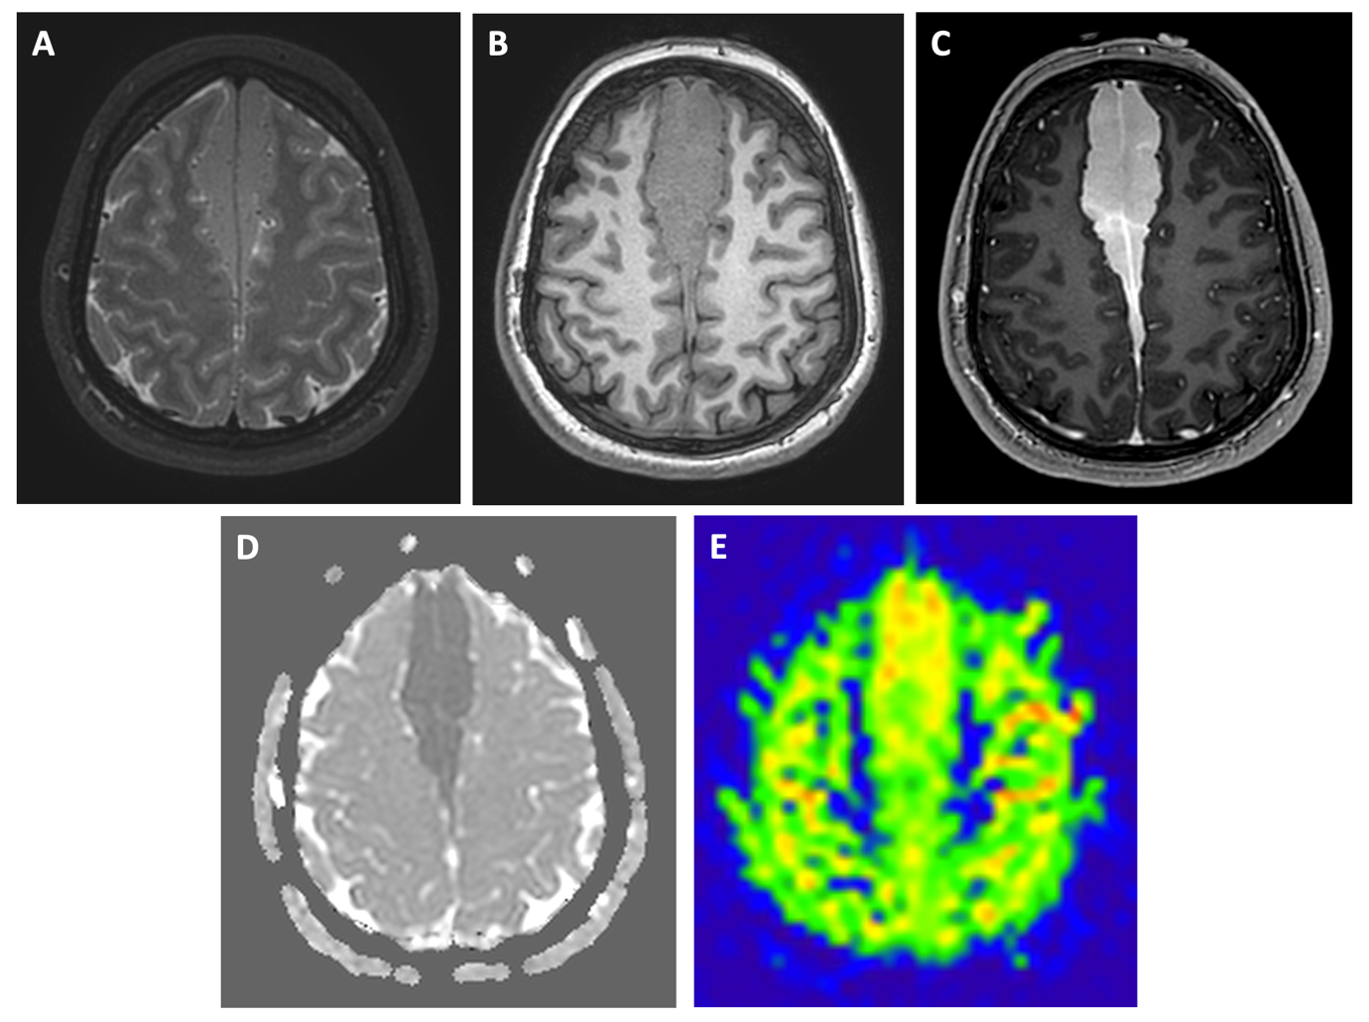
Figure 1. Preoperative brain MRI data. A - axial T2-weighted images; B - axial precontrast T1-weighted images (tumor has slight hyperintense signal compared to gray matter); C - axial postcontrast T1-weighted images (there is prominent homogeneous contrast enhancement); D - on ADC map, tumor demonstrates very low ADC-values; E - there is no hypoperfusion according to ASL data.

There was minimal edema of the peritumoral brain tissue and no signs of invasion; there was slight intrinsic signal hyperintensity in the precontrast T1-WI (Figure 1b) and very low apparent diffusion coefficient (ADC) values (approximately 400*10⁻⁶ mm²/sec, Figure 1d); however, there were no signs of hypoperfusion according to ASL data (CBF value was approximately 45 ml/100 ml/min, Figure 1e).
These neuroimaging findings were interpreted as consistent with meningioma. Thus, the preoperative diagnosis was a falx meningioma, and no additional examinations were performed.
The surgery was performed under general anaesthesia by bilateral parasagittal craniotomy using a bilateral interhemispheric approach (Figure 2).

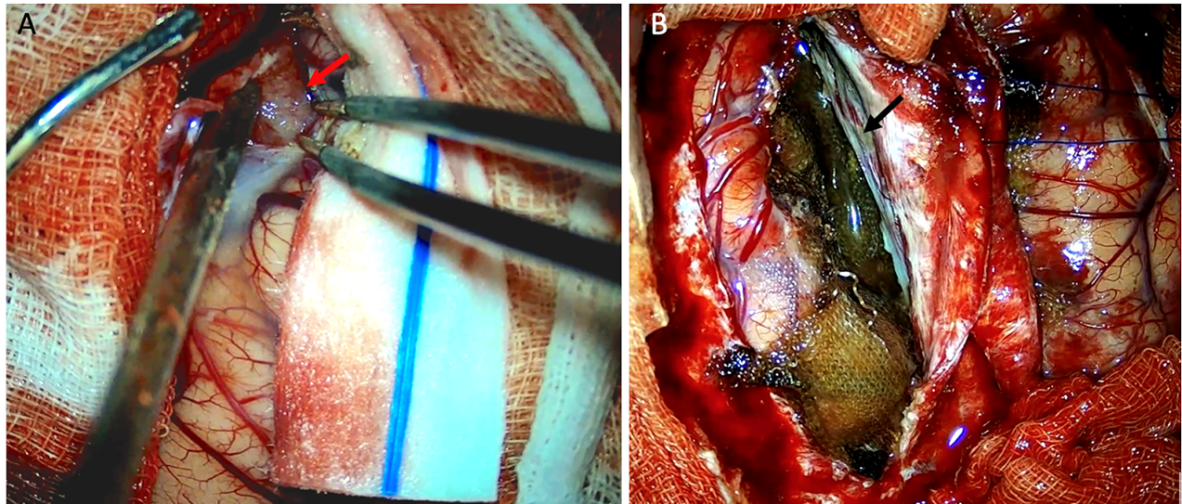
Figure 2. Intraoperative data. A – Interhemispheric fissure dissection from the right side (tumor marked by red arrow). B - Intraoperative view after tumor resection. Lateral wall of the superior sagittal sinus (black arrow).

Intraoperatively, the tumor had all the macroscopic characteristics of meningioma - it appeared to have infiltrative growth and had a wide "matrix" on both sides of the falx cerebri; moreover, there was no discernible dissection plane between the tumor and brain tissue. The first step of surgery included internal decompression of the tumor from the right side (to prevent possible language function impairment) using an ultrasound disintegrator. Then, resection of the falx cerebri was performed. In the second step, when brain relaxation was achieved, tumor resection was performed from the left side. Intraoperative blood loss was 650 ml. There was mild transient left-sided hemiparesis immediately after surgery with complete recovery up to discharge within 10 days. No additional neurological deficits were detected. Figure 3 shows the early postoperative MRI with tumor resection results.

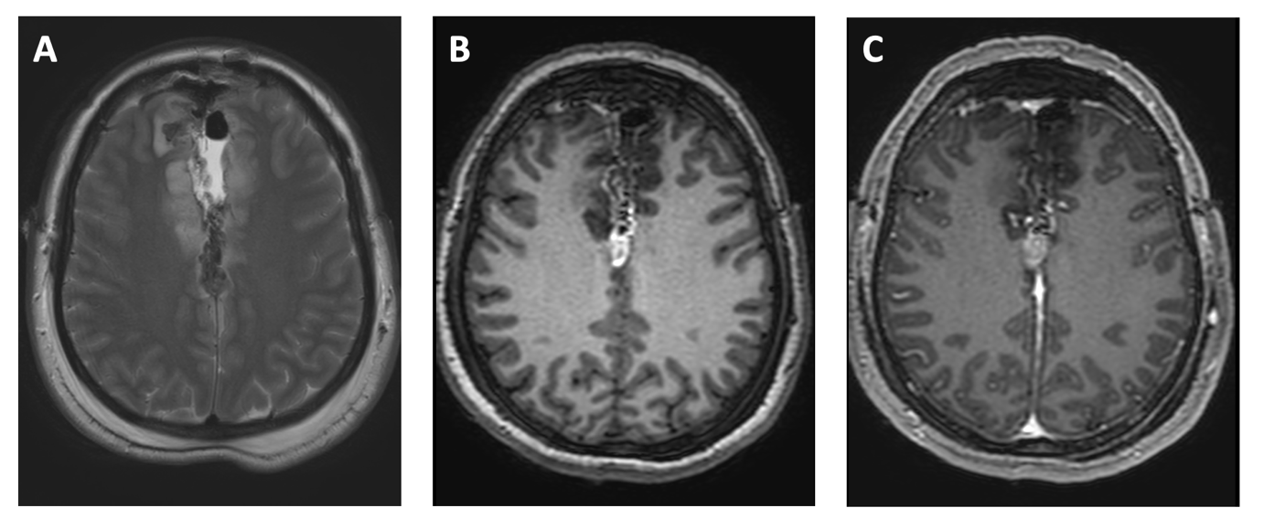
Figure 3. Early postoperative brain MRI data. A - axial T2-weighted images; B - axial precontrast T1-weighted images (tumor has slight hyperintense signal compared to gray matter); C - axial postcontrast T1-weighted images (there is prominent homogeneous contrast enhancement).

Histological examination showed the absence of meningothelial components. There was diffuse infiltration of lymphocytes and plasma cells, with the formation of germinative centers (Figure 4a).

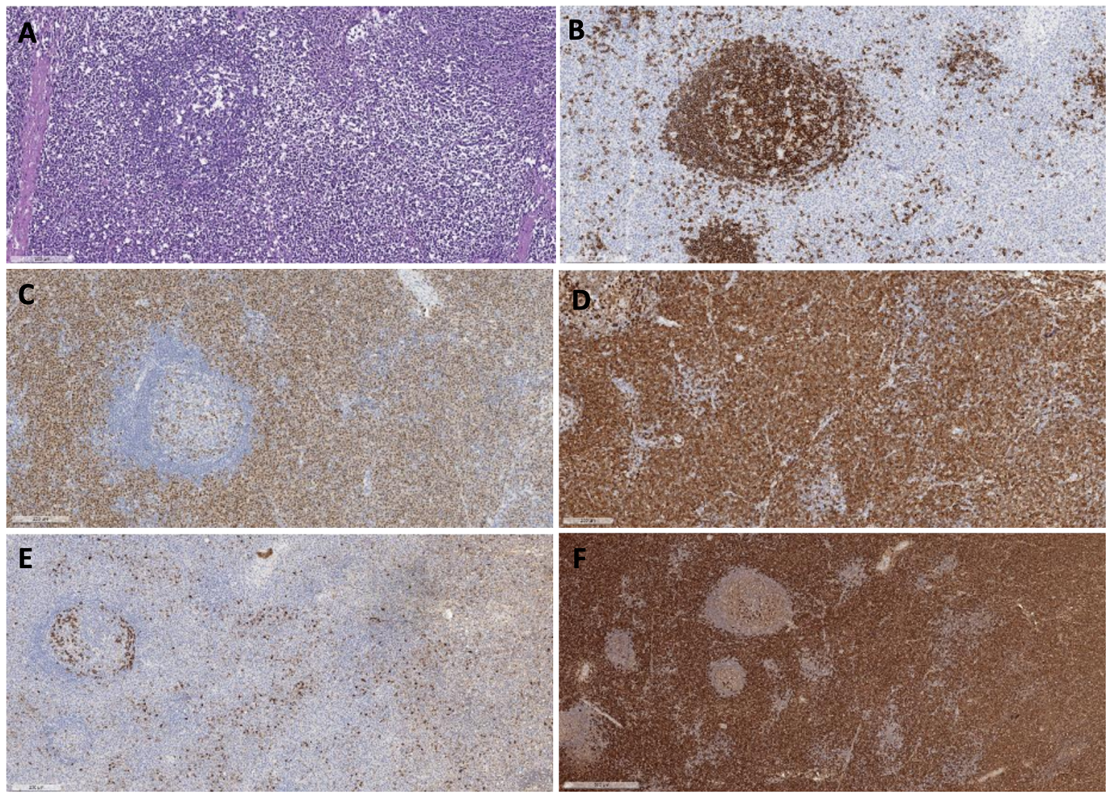
Figure 4. Morphology of tumor specimens. A - Hematoxylin-eosin staining shows diffuse infiltration of small lymphocytes and plasma cells (x100). Immunohistochemical examinations show positive staining for CD20 (B), MuM1 (C), and CD79a (D). The plasma cells are positive for lambda immunoglobulin light chain (E) and kappa light chain expression (F).

Lymphocytes were positive for CD20, CD79a and multiple myeloma 1, suggesting B-cell lymphoma (Figure 4b, 4c, and 4d). Furthermore, there was positive staining for B-cell lymphoma 2, lambda light chain, and kappa light chain. Cells within germinative centers were positive for CD3, CD23, and CD10 antigens. The Ki-67 labelling index was 38%. Immunohistochemical markers such as CD138, CyclinD1, and B-cell lymphoma 6 were negative. The final histopathological diagnosis was MALT lymphoma.
Systemic screening examinations were then performed. Chest and abdominal CT with contrast enhancement did not reveal additional tumor foci or lymphadenopathy. The patient was consulted by an oncologist and hematologist, and taking into account that the lesion was solitary and totally surgically resected, no adjuvant treatment was administered. Follow-up brain MRI at 3 months did not reveal tumor progression.

Discussion
Primary dural lymphoma is a rare subtype of primary CNS lymphoma that originates in the dura mater and usually does not infiltrate the brain parenchyma (6). These tumors usually have nonspecific symptoms such as headaches, seizures, scalp swelling, and cranial nerve involvement. Morphologically, PDL is a B-cell lymphoma of the marginal zone; it is a low-grade and slowly growing tumor that more frequently occurs in the gastrointestinal system (MALT lymphoma) (7). There are usually no infiltrative aspects or systemic involvement (8). PDLs have a very favorable prognosis with a 5-year overall survival of approximately 86% (6).
Although some case reports and case series of PDL cases have been published, the exact incidence of PDL is unknown (5). PDL is believed to be more common in women than in men, with an average age of diagnosis of approximately 50-60 years old (9). In our case, PDL was revealed in a young woman (36 years old), which made exact presurgical diagnosis even more difficult. Most published cases reported older patients with primary CNS lymphomas (7,9,10). However, several case reports have described young patients with PDL (11, 12).
In computer tomography and magnetic resonance imaging, MALT dural lymphomas are very similar to meningiomas. Therefore, they are usually misdiagnosed at first. In this patient, the tumor presented with a solid extra-axial contrast-enhancing lesion with a “dural tail” sign (filiform prolongation of the dura, suggestive but not specific for meningiomas)(13). However, in our case, there was also a slight T1-WI signal hyperintensity from the tumor compared to brain tissue, as well as very low ADC values (approximately 400 * 10⁻⁶), which unfortunately was not taken into account. Primary CNS lymphomas usually have very low ADC values (14); however, meningiomas could also have low ADC values (15), and several studies even showed that it could be associated with tumor grade (16). On the other hand, in our case, hypoperfusion within tumor tissue was not detected (CBF values were approximately 40 ml/100 ml/min according to ASL); however, it is well known that primary CNS lymphomas tend to have low perfusion values (17). Thus, it was very difficult to suspect dural lymphoma.
Another differential diagnostic possibility in the case of dural lymphomas is subdural hematoma (18,19), especially when head CT only is performed. However, it was not appropriate in our case due to the parasagittal tumor location. Other differential diagnoses of dural-based lesions include neurosarcoidosis, aspergillosis, dural metastases, postradiation or postsurgical dural reaction (5). It should be noted, however, that neuroimaging data alone are not sufficient for PDL diagnosis, and clinical information (with detailed medical history) is crucial.
Various treatments for primary dural MALT lymphoma have been reported previously. However, because no studies have evaluated different treatment options, the standard treatment regimen for these tumors has not yet been defined (20). It is believed that surgical resection of primary CNS lymphoma affects patient overall survival and progression-free survival and should be performed when possible (21,22,23). However, PDL is a low-grade tumor and is known to be very radiosensitive (20); thus, total excision seems not to have an impact on overall survival. Nevertheless, in most published cases of PDL patients, tumor resection was performed, followed by radiosurgery and/or chemotherapy (24). This can be easily explained by presurgical diagnostic mistakes, as in our case.
In our case, chemotherapy with no adjuvant treatment was prescribed, and the patient is currently under observation with no signs of disease progression during the 3-month follow-up period. This decision was made taking into account that it was a solitary lesion that had been totally surgically resected. There is some evidence that aggressive surgery may be a basis for favorable outcomes in patients with PDL (3); however, prospective clinical trials with long-term follow-up are clearly needed in this field.
Although there are limited reports and primary dural MALT lymphoma is rare, more research is required in this field to develop the most effective presurgical diagnostic algorithms and the optimal treatment strategy.

Conclusion
Diagnostic errors can cause delays in pathogenetic treatment of primary dural lymphoma. Thus, PDL should be considered in the differential diagnosis of meningiomas.

Abbreviations
ADC: apparent diffusion coefficient; CBF: cerebral blood flow; CNS: central nervous system; CT: computer tomography; MALT: mucosa-assisted lymphoid tissue; MRI: magnetic resonance tomography; PDL: primary dural lymphoma.

Declarations

Ethics approval and consent to participate
Data acquisition and publication were in accordance with the principles outlined in the Declaration of Helsinki. The local ethics committee BLINDED has confirmed that no ethical approval is needed.

Consent for publication
Written informed consent was taken from the patient. The identity of the patient is not revealed in the pictures or in the manuscript.

Availability of data and material
Data can be provided by the corresponding authors upon request.

Competing interests
The authors declare that they have no competing interests.

Funding
No funding.

Acknowledgements
None

Correspondence
 | Oleg M. Andrushkevich
✉︎ | Federal Center of Neurosurgery Novosibirsk, Russia, Nemirovich-Danchenko Str. 132/1, Novosibirsk 630087, Russia
☏ | +79130191991
@ | andrushkevich_oleg@mail.ru

References
- Dobran M, Paracino R, Mancini F, Nasi D. Primary dural lymphoma: clinical cases and literature review. Case Rep Med. 2020:2812487.
- La Rocca G, Auricchio AM, Mazzucchi E, Ius T, Della Pepa GM, Altieri R, et al. Intracranial dural based marginal zone MALT-type B-cell lymphoma: a case-based update and literature review. Br J Neurosurg. 2021.
- Karschnia P, Batchelor TT, Jordan JT, Shaw B, Winter SF, Barbiero FJ, et al. Primary dural lymphomas: clinical presentation, management, and outcome. Cancer. 2020;126(12):2811-2820.
- Pavlou G, Pal D, Bucur S, Chakrabarty A, Van Hille PT. Intracranial non-Hodgkin’s MALT lymphoma mimicking a large convexity meningioma. Acta Neurochir. 2006;148(7):791-793.
- Lopetegui-Lia N, Delasos L, Asad SD, Kumar M, Harrison JS. Primary central nervous system marginal zone B-cell lymphoma arising from the dural meninges: a case report and review of literature. Clin Case Rep. 2020;8(3):491-497.
- Lv ZW, Cheng KL, Tian HJ, Han XM. Primary diffuse large B-cell lymphoma of the dura with skull and scalp involvement: a case report and brief review of the literature. Oncol Lett. 2016;11(6):3583-3588.
- Kumar S, Kumar D, Kaldjian EP, Bauserman S, Raffeld M, Jaffe ES. Primary low-grade B-cell lymphoma of the dura: a mucosa associated lymphoid tissue-type lymphoma. Am J Surg Pathol. 1997;21(1):81-87.
- de Azevedo Rosas F, Favareto SL, Vieira GM, de Oliveira MN, D’Almeida Costa F, de Castro DG. Marginal zone lymphoma of the dura — two case reports with long-term follow-up. Rep Pract Oncol Radiother. 2021;26(1):138.
- Sebastián C, Vela AC, Figueroa R, Marín MÁ, Alfaro J. Primary intracranial mucosa-associated lymphoid tissue lymphoma. A report of two cases and literature review. Neuroradiology J. 2014;27(4):425-430.
- Partovi S, Karimi S, Lyo JK, Esmaeili A, Tan J, Deangelis LM. Multimodality imaging of primary CNS lymphoma in immunocompetent patients. Br J Radiol. 2014;87(1036).
- Ferguson SD, Musleh W, Gurbuxani S, Shafizadeh SF, Lesniak MS. Intracranial mucosa-associated lymphoid tissue (MALT) lymphoma. J Clin Neurosci. 2010;17(5):666-669.
- Raguž M, Mudrovčić Y, Dlaka D, Almahariq F, Romić D, Tomasović-Lončarić Č, et al. Primary dural lymphoma mimicking meningioma: a clinical and surgical case report. J Surg Case Rep. 2018;2018(8):1-4.
- Wallace EW. The dural tail sign. Radiology. 2004;233(1):56-57.
- Eisenhut F, Schmidt MA, Putz F, Lettmaier S, Fröhlich K, Arinrad S, et al. Classification of primary cerebral lymphoma and glioblastoma featuring dynamic susceptibility contrast and apparent diffusion coefficient. Brain Sci. 2020;10(11):886.
- Meyer HJ, Wienke A, Surov A. ADC values of benign and high grade meningiomas and associations with tumor cellularity and proliferation - a systematic review and meta-analysis. J Neurol Sci. 2020;415:116975.
- Surov A, Gottschling S, Mawrin C, Prell J, Spielmann RP, Wienke A, Fiedler E. Diffusion-weighted imaging in meningioma: prediction of tumor grade and association with histopathological parameters. Transl Oncol. 2015;8(6):517.
- Di N, Cheng W, Chen H, Zhai F, Liu Y, Mu X, et al. Utility of arterial spin labelling MRI for discriminating atypical high-grade glioma from primary central nervous system lymphoma. Clin Radiol. 2019;74(2):165.e1-165.e9.
- Gocmen S, Gamsizkan M, Onguru O, Sefali M, Erdogan E. Primary dural lymphoma mimicking a subdural hematoma. J Clin Neurosci. 2010;17(3):380-382.
- Thibodeau R, Li HK, Babu H, Jafroodifar A, Ramovic M, Hahn SS. Dural lymphoma misdiagnosed as subdural hematoma following head trauma after an episode of syncope. Radiol Case Rep. 2022;17(12):4774-4779.
- Takeuchi I, Tanei T, Kuwabara K, Kato T, Naito T, Koketsu Y, et al. Primary dural mucosa-associated lymphoid tissue lymphoma mimicking falx meningioma: a case report. NMC Case Rep J. 2022;9(0):123.
- Chojak R, Koźba-Gosztyła M, Polańska K, Rojek M, Chojko A, Bogacz R, et al. Surgical resection versus biopsy in the treatment of primary central nervous system lymphoma: a systematic review and meta-analysis. J Neuro Oncol. 2022;160(3):753-761.
- Deng X, Xu X, Lin D, Zhang X, Yu L, Sheng H, et al. Real-world impact of surgical excision on overall survival in primary central nervous system lymphoma. Front Oncol. 2020;10:515153.
- Schellekes N, Barbotti A, Abramov Y, Sitt R, Di Meco F, Ram Z, Grossman R. Resection of primary central nervous system lymphoma: impact of patient selection on overall survival. J Neurosurg. 2021;135(4):1016-1025.
- Bayraktar S, Stefanovic A, Montague N, Davis J, Murray T, Lossos IS. Central nervous system manifestations of marginal zone B-cell lymphoma. Ann Hematol. 2010;89(10):1003-1009.

