  - CASE REPORT

Tibial nerve schwannoma: a case report
  - Aleksić Radmila1, Aleksić Vuk2, Lazić Aleksandar3, Oroz Aleksandar1, Miladinović Nenad4, Miladinović Nebojoša5

- Department of head and neck surgery, Clinical hospital Center Zemun, Belgrade, Serbia
- Department of neurosurgery, Clinical hospital Center Zemun, Belgrade, Serbia
- Department of surgery, Clinical hospital Center Zemun, Belgrade, Serbia
- Department of pathology, Clinical hospital Center Zemun, Belgrade, Serbia
- Department of orthopedics and traumatology, Clinical hospital Center Zemun, Belgrade, Serbia

Abstract
Schwannoma represents a benign, slow growing, well-defined, solitary nerve sheath tumor that frequently occurs in the region of the head, neck and spine.
We present a case of a 35-year women who had pain in the right leg for 10 years, and after multiple failed treatment attempts, she was finally diagnosed and afterwards operated for tibial nerve schwannoma of the right leg in the middle portion of the shin. This rare localization and the absence of a palpable mass led to a long-term delay in accurate diagnosis.
This case illustrates that a properly taken medical history and a profound clinical examination cannot be replaced by any other diagnostic test, and apart from fallowing standard guidelines for clinical practice, personalized medical approach is still conditio sine qua non.
Keywords: schwannoma, leg pain, tibial nerve
DOI:

Introduction
Schwannoma represent a benign tumor that originates from the peripheral nerve sheath. Most often it occurs as a small, palpable, tender nodule associated with pain or paresthesia when compressed. The growth rate is usually slow, and these lesions rarely exceed 2 cm in diameter (1). Differential diagnosis of leg pain is extensive and include: lumbar disc disease, arthritis, muscle cramps, gout, arterial occlusion or vein thrombosis, intermittent claudication, infection, medial tibial stress syndrome (shin splints), different types of neuropathy, diabetic amyotropy, complex regional pain syndrome, tarsal tunnel syndrome, tumors, trauma, and many more other causes (2).
We present a case of a 35-year women who had pain in the right leg for 10 years, and after multiple failed treatment attempts, she was finally diagnosed and afterwards operated for tibial nerve schwannoma of the right leg in the middle portion of the shin. In our case, a detailed clinical evaluation was a central part of the diagnostic process. It was shown that a properly taken history and a detailed clinical and neurological examination cannot be replaced by any other diagnostic test. The principle that must guide clinicians is that the patient is always the center of attention or Salus aegroti – suprema lex medicorum.

Report
A 35-years women was sent to our clinic for neurological exam and therapy because of the chronic leg pain

in her right leg that lasted for more than 10 years. The pain was localized in the calf of the right leg and became more severe over time. In the last few months before the examination, the pain began to spread to the foot, which patient described as electrical shocks that descend to the foot. Compression of the patient’s hamstrings worsened the pain. Patient had multiple failed treatment attempts, and during her last physical therapy lumbar spine magnetic resonance imaging (MRI) was performed which is why a consultative examination by a neurosurgeon was requested. Upon examination neurological finding indicated peripheral neuropathy with positive Tinnel sign in the region of the medial portion of the right calf, with pronounced paresthesia in the skin of the right heel and the sole of the foot during calf compression. Also, she had localized pain in the right calf, which has increased significantly in the last few months. However, no palpable mass was noted. Lazarević sign was negative. Differential diagnosis included discal herniation with radiculopathy, nerve entrapment syndromes, peripheral nerve sheet tumors, soft tissue tumors, as well as vascular and neurogenic claudication’s. Lumbar spine MRI indicated minimal degenerative changes with polydiscopathy, but could not explain the patient's symptoms and clinical findings. Lower leg soft tissue ultrasound demonstrated well circumscribed oval lesion in the region of the middle third of the calf muscles of the right leg with diameter of 45 mm. The lesion had clear contours with large central calcification (picture 1).

Picture 1. Lower leg soft tissue ultrasound demonstrating well circumscribed oval lesion in the region of the middle third of the calf muscles.

MRI of the right leg was performed and demonstrated encapsulated oval shaped lesion within the intermuscular space in the posterior aspect of lower leg, between deep calf muscles in the curse of tibial nerve. Tumor showed homogenous isointense on T1 and heterogeneous hyperintense signal on T2 MRI sequence, and the finding was indicative of tibial nerve schwannoma (picture 2).
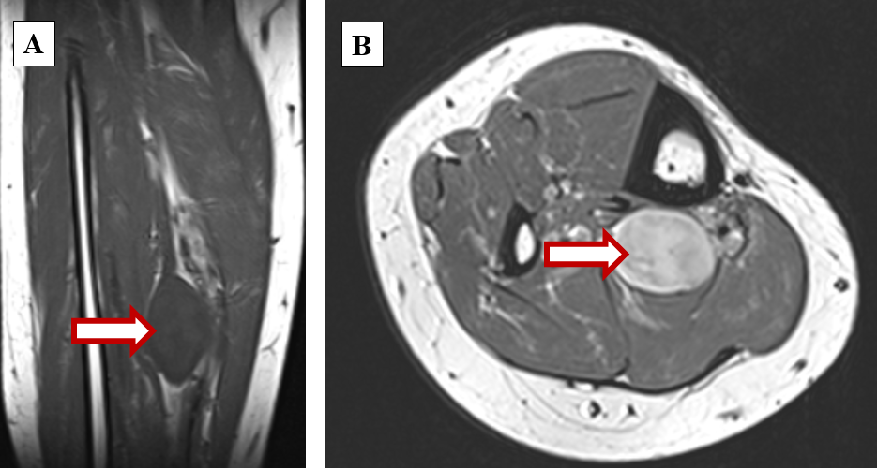
Picture 2. MRI of the right leg showing encapsulated oval shaped lesion within the intermuscular space in the posterior aspect of lower leg in the curse of tibial nerve. Tumor showed homogenous isointense on T1 (A) and heterogeneous hyperintense signal on T2 (B) MRI sequence. Arrows are pointing at the lesion.

Patient was operated under general anesthesia with microsurgical technique. After incising the epineurium of tibial nerve, tumorous lesion measuring about 3x4 cm in diameter was removed after meticulous preparation of surrounding nerve fascicules. This intracapsular approach was chosen, which enabled the removal of the tumor without additional damage to nerve function, e.g. the principle implies enucleation with gentle opening and longitudinal tumor capsule incision, separating the surrounding nerve fascicles under large magnification using operative microscope (picture 3).

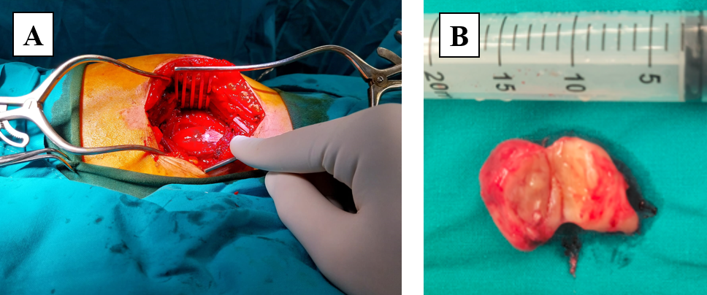
Picture 3. (A) Intraoperative view of tumor. (B) The tumor cut in half after removal in one piece.

Fortunately, there was no disruption of tibial nerve continuity, and tumor was completely removed. Postoperative period was uneventful, and the patients was discharged home on the 3th postoperative day. Histopathological examination of the lesion confirmed presumed diagnosis of ancient schwannoma (picture 4).

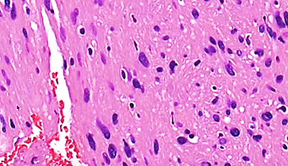
Picture 4. Histopathological finding indicative of the ancient schwannoma.

The patient was regularly followed up at timely intervals for one year since the excision of the lesion. The patient was without recurrence of tumor during the follow-up period, and she was completely pain free immediately after operation, without neurological deficit.

Discussion
Schwannoma is a peripheral nerve sheet slow growing tumor, also known as neurilemoma, neurocytoma, peripheral gliomas, and neurinoma. It is the most common peripheral nerve tumor, and usually is presented as an asymptomatic, slow-growing, solitary, firm, well-circumscribed, encapsulated and palpable tumor (3). They are usually find in the head, neck and spine, while other locations are rare (4). Schwannomas are most frequent in adults between the ages of 30 and 60, and they affect both men and women equally. Most schwannomas are asymptomatic however they can cause functional deficits and pain depending on which nerve is affected. Most common peripheral nerve sheet tumors are schwannomas, followed by neurofibromas, hybrid nerve sheath tumors and perineuriomas (5). Although schwannoma represents a rare entity with incidence of about 5 cases per 100,000, they are the most common type of peripheral nerve tumors in adults. On the other hand, malignant peripheral nerve sheath tumor is a rare and aggressive type of sarcoma with incidence reported to be 1 in 100,000 adults per year, accounting for about 5 to 10% of all soft tissue sarcomas. We present a 35-years-old female patient with schwannoma in the rare location, between deep calf muscles involving the main trunk of the tibial nerve.
Schwannomas cause a varied symptomatology from asymptomatic phase to severe phase of nerve involvement with wide spectrum of clinical symptoms such as parasthesias, hypoesthesia, tingling, motor weakness, and positive Tinel's sign (6). Although, chronic leg pain can be caused by variety of causes, detailed anamnesis, and precise clinical and neurological examination can significantly narrow the differential diagnosis (2). Perineurioma symptoms differ from other peripheral nerve sheet tumors, presenting as a mononeuropathy of slow onset and gradual progression, resulting in neurological deficits like hypoesthesia or, much more frequently, a muscular weakness but, rarely with a positive Tinel’s sign. In about 60% of the other patients, a Tinel’s sign was triggered by tapping. This corresponds with the data in the literature that the Tinel’s sign is highly indicative for a peripheral nerve sheet tumor and should lead to further diagnostics (7). In our patient peripheral neuropathy with positive Tinnel sign in the region of the medial portion of the right calf was present.
Among all radiological modalities, MRI is a gold standard for the diagnosis of peripheral nerve sheet tumors. MRI enhanced the preoperative diagnosis of nerve sheath tumors and provided information regarding the tumor characteristics, such as size, precise location, and relationship with surrounding structures. Nevertheless, the clinical preoperative diagnosis of schwannoma is often difficult because of its slow growing nature, high mobility, soft tissue texture, sometimes painless nature, and clinical symptoms that are shared with other conditions. Although a precise diagnosis is not possible only on the basis of radiological images, the MRI findings can indicate differences between malignant peripheral nerve sheath tumors and benign tumor lesions, especially neurofibromas based on several factors such as the largest dimension of the tumor mass, peripheral enhancement pattern after contrast administration, type of perilesional edema, and presence of cystic component in the tumor (8). Schwannomas may be misdiagnosed as fibromas, gangliomas, lipomas, or xanthomas (9). Phalen reported accurate diagnosis of schwannoma in one third of upper extremity schwannoma patients (10). Although peripheral nerve sheath tumors are relatively rare entity, general practitioners and doctors of all specialties must suspect the presence of such tumor as one of the possible diagnoses in the case of body or limb tumor. The time to diagnosis (TTD) as a factor in disease prognosis is increasingly in the focus of clinicians and is an important factor in the prognosis of many diseases (11). Also, complete failure of therapy should raise the suspicion of a possible other diagnosis. In the study of Uerschels et al. prolonged conservative treatment was present in 28.9% with peripheral nerve sheet tumors, resulting in pronounced neurological deficit in two patients and neuropathic pain syndrome in 5 patients (7). Our case is interesting since patient had symptoms for more than 10 years, and for many years she was treated for suspected lumbar disc herniation. This case illustrates that a properly taken medical history and a profound clinical examination cannot be replaced by any other diagnostic test, and apart from fallowing standard guidelines for clinical practice, personalized medical approach is still conditio sine qua non.
Treatment for schwannoma is determined by the location of the tumor, if it is causing pain, and how rapidly it grows. Sometimes observation is indicated, but surgery is essential if symptoms occur or suddenly worsen, or when malignant alteration is suspected, which was also one of the most important reason for our patient’s surgery, since she had a significant increase in pain in the last few months. Main goal is enucleating the tumor while avoiding nerve damage with internal neurolysis, so usage of operative microscope is strongly recommended (6). In most of the cases schwannomas are eccentrically located and do not involve the main nerve trunk, but tend to displace the nerve fibers peripherally in contrast to neurofibromas, which grow within the nerve fibers, potentially necessitating the partial or complete resection of nerve fibers, resulting in nerve deficit (7). In our case all nerve fibers were preserved by meticulous preparation, and this finding was also indicative of schwannoma. After performed operation our patient didn’t have any postoperative complication nor neurological deficit.

Conclusion
Schwannoma is a peripheral nerve sheet tumor. Diagnosis is difficult when the tumor is in rare location, especially if the tumor is not palpable. However, a well-taken medical history and a detailed clinical and neurological examination are indispensable tools for making the right diagnosis. Also, in cases of radicular leg pain, one of the differential diagnoses should always be a peripheral nerve tumor.

Disclosures
Conflict of Interest: All authors certify that they have no affiliations with or involvement in any organization or entity with any financial interest (such as honoraria; educational grants; participation in speakers' bureaus; membership, employment, consultancies, stock ownership, or other equity interest; and expert testimony or patent-licensing arrangements), or non-financial interest (such as personal or professional relationships, affiliations, knowledge or beliefs) in the subject matter or materials discussed in this manuscript.
Informed consent: Informed consent was obtained from all individual participants included in the study.
Funding: No funding was received for this research.

Correspondence
 | Vuk Aleksić
✉ | Department of neurosurgery, Clinical hospital Center Zemun  Vukova 9, Belgrade, Serbia
☏ | +381 (0)64 1180-683
@ | aleksicvuk@hotmail.com

References
- Kumar R, Ranjan R, Jeyaraman M, Kumar S. Tibial Nerve Schwannoma: An Unexplained Cause of Lateral Foot Pain - A Rare Case Report and Review. J Orthop Case Rep. 2020 Dec;10(9):1-6.
- Edwards PH Jr, Wright ML, Hartman JF. A practical approach for the differential diagnosis of chronic leg pain in the athlete. Am J Sports Med. 2005 Aug;33(8):1241-9.
- Maraziotis T, Panagiotopoulos E, Panagiotopoulos V, Panagiotopoulos K. Neurilemoma of the popliteal fossa:Report of two cases with long subclinical course and misleading presentation. Acta Orthop Belg. 2005;71:496–9.
- Han KJ, Lee YS, Park M. Digital nerve schwannoma of the hand. J Hand Surg Eur Vol. 2012 May;37(4):361-2.
- Galbiatti JA, Milhomens GRDS, Bertozzo LG, Escames L, Milhomens Neto PA, Galbiatti MGP. Retrospective Analysis of 20 Patients Affected by Schwannomas in the Upper and Lower Limbs. Rev Bras Ortop (Sao Paulo). 2020;55(5):629-636.
- Aleksić V, Prelić J, Radojević M, Ćulafić R. Schwannoma of the digital nerve. A rare case report. Romanian neurosurgery. 2021;35(4):490-492.
- Uerschels AK, Dengler NF, Chihi M, Lenkeit A, Dinger TF, Jabbarli R, Sure U, Hagenacker T, Wrede KH, Gembruch O. Benign peripheral nerve sheath tumors: an interdisciplinary diagnostic and therapeutic challenge. Neurosurg Rev. 2023 Aug 18;46(1):205
- Wasa J, Nishida Y, Tsukushi S, Shido Y, Sugiura H, Nakashima H, Ishiguro N. MRI features in the differentiation of malignant peripheral nerve sheath tumors and neurofibromas. AJR Am J Roentgenol. 2010 Jun;194(6):1568-74
- Chelsea P, Ghazle H, Bhatt S, Dogra V. Schwannoma of the Tibial nerve. Journal of Diagnostic Medical Sonography. 2010;26(4):205-208.
- Phalen GS. Neurilemomas of the forearm and hand. Clin Orthop Relat Res. 1976;114:219–222.
- Launay E, Cohen JF, Bossuyt PM, Buekens P, Deeks J, Dye T, Feltbower R, Ferrari A, Kramer M,
- Leeflang M, Moher D, Moons KG, von Elm E, Ravaud P, Chalumeau M. Reporting studies on time to diagnosis: proposal of a guideline by an international panel (REST). BMC Med. 2016;14(1):146.

