  - CASE REPORT

Transnasal Transsphenoidal Extradural Chiasmopexy Using Attainable Autologous Material in Syptomatic Secondary Empty Sella Syndrome
  - Petar Vuleković, MD, PhD^{1,2}; Dušan Rodić, MD¹; Bojan Jelača, MD, PhD^{1,2}; Nebojša Lasica, MD^{1,2}; Vladimir Kljajić, MD, PhD^{2,3}; Milica Medić Stojanoska, MD,PhD^{2,4}; Ivana Bajkin, MD, PhD^{2,4}; Nikola Boban, MD⁵; Desanka Grković, MD, PhD^{2,6}.

1. Clinic of Neurosurgery, University Clinical Center of Vojvodina, Novi Sad, Serbia.
2. Faculty of Medicine, University of Novi Sad, Novi Sad, Serbia.
3. Clinic for Otorhinolaryngology and Head and Neck Surgery, University Clinical Center of Vojvodina, Novi Sad, Serbia.
4. Clinic for Endocrinology, Diabetes and Metabolic disorders, University Clinical Centre of Vojvodina, Novi Sad, Serbia.
5. Center for Radiology, University Clinical Center of Vojvodina, Novi Sad, Serbia.
6. Eye Clinic, University Clinical Center of Vojvodina, Novi Sad, Serbia.

Abstract
Secondary Empty Sella Syndrome (SESS) is a rare condition characterized by the herniation of the subarachnoid space into the empty sella turcica leading to dislocation and may lead to impairment in the optic system (nerves, chiasm and tracts). This report represents a case of symptomatic SESS following cabergoline therapy for prolactinoma causing vision impairment. The patient was surgically treated by endoscopic transnasal transsphenoidal approach and extradural chiasmopexy. The surgical procedure involves repositioning and fixation of damaged optic nerves and chiasm using attainable autologous material from bone and cartilage graft harvested from the nasal septum. The postoperative course was uneventful. The patient’s visual impairment regressed on follow up. The use of attainable autologous grafts excludes the need for synthetic materials, reduces the risk of graft rejection additional donor-site surgeries, and postoperative complications.

Keywords: chiasmopexy; empty sella; endoscopic endonasal approach; prolactinoma; pituitary surgery; cabergoline.
DOI:

Introduction:
Secondary Empty Sella Syndrome (SESS) is a rare condition characterized by the presence of cerebrospinal fluid (CSF) filling of sella turcica after the partial or complete herniation of the arachnoid through the diaphragma sellae.¹ This challenging condition may develop after the surgical treatment, radiation or medical management of pituitary adenomas. Symptomatic SESS develops as a result of withdrawal of adenoma tissue and secondary expansion of the subarachnoid space into the empty sella turcica leading to dislocation and damage to the optic system (nerves, chiasm and tracts).²⁻⁵
Chiasmopexy is a surgical procedure that elevates and stabilizes the optic system and prevents further damage, and has been a standard treatment for patients with symptomatic SESS.⁶ However, the optimal approach and graft material for chiasmopexy remains a subject of debate. In our case, we describe successful management strategy for symptomatic SESS using endoscopic transnasal transsphenoidal approach with extradural chiasmopexy with attainable autologous material from septal bone and cartilage.^{7,8}
Case Presentation:
A 53-year-old male presented with a history of prolactinoma managed with cabergoline therapy for 4 years (Figure 1). After three years, the patient developed with gradual visual deterioration with prolactin levels within the normal range. Neuroophtalmological examination revealed bitemporal visual field defects. Follow-up magnetic resonance imaging (MRI) demonstrated a reduction in prolactinoma volume with development of symptomatic secondary empty sella, and significant dislocation of the optic system (Figure 2,3,4).

Figure 1. Initial MRI of sellar region prior to medical management of prolactinoma.
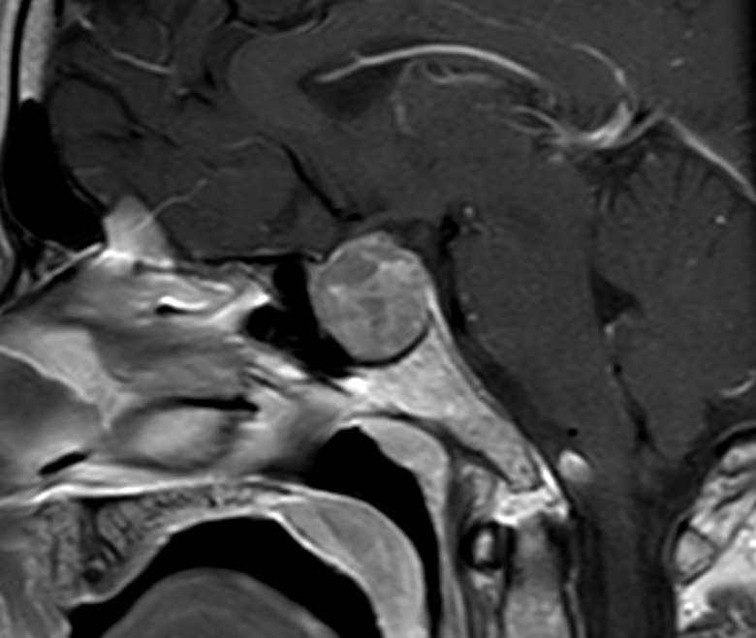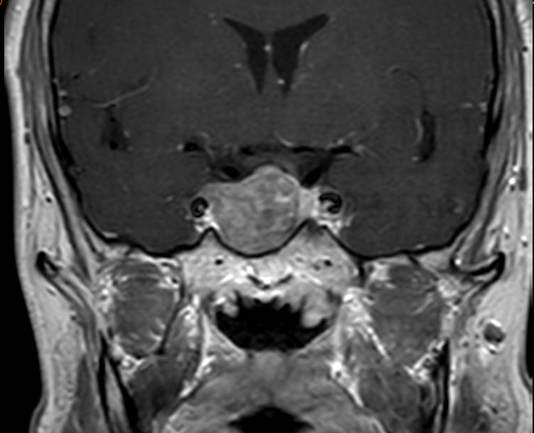
Figure 2. Follow-up MRI of sellar region 8 months after the initiation of cabergoline treatement.
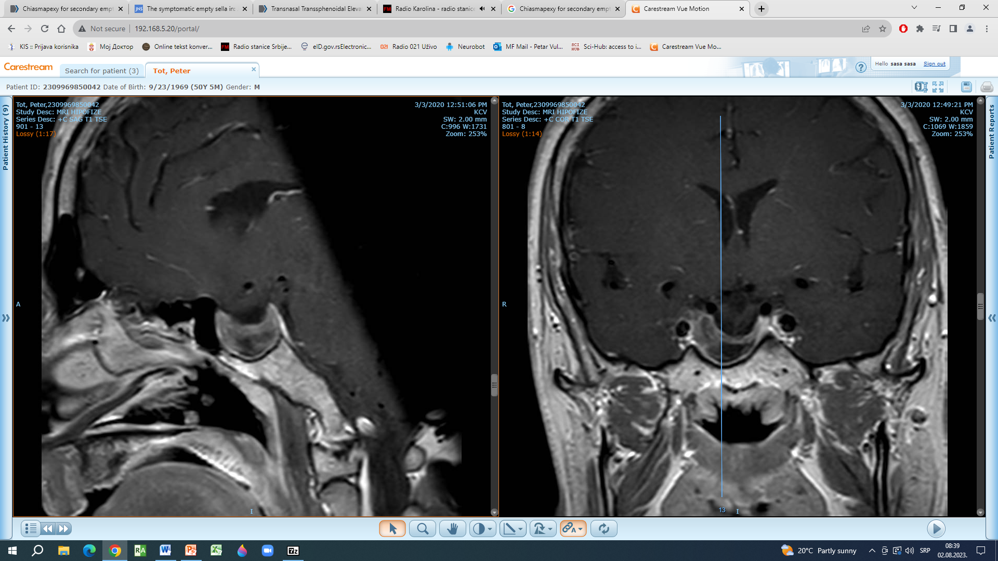
Figure 3. Second follow-up MRI of sellar region after 21 months of cabergoline use.
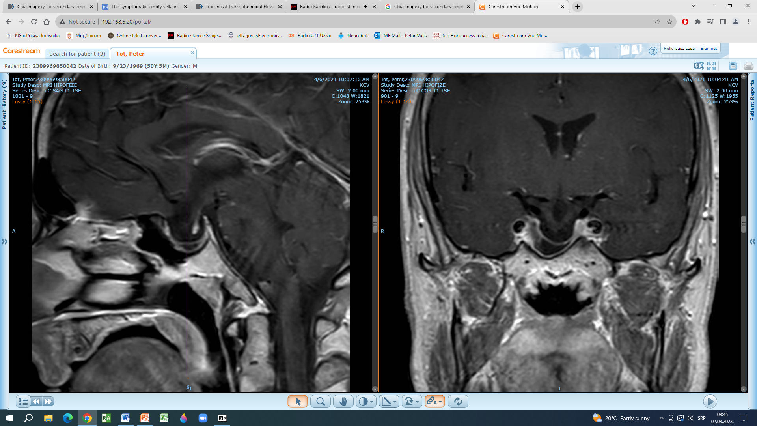
Figure 4. Third follow-up MRI of sellar region after 4 years of cabergoline treatement.
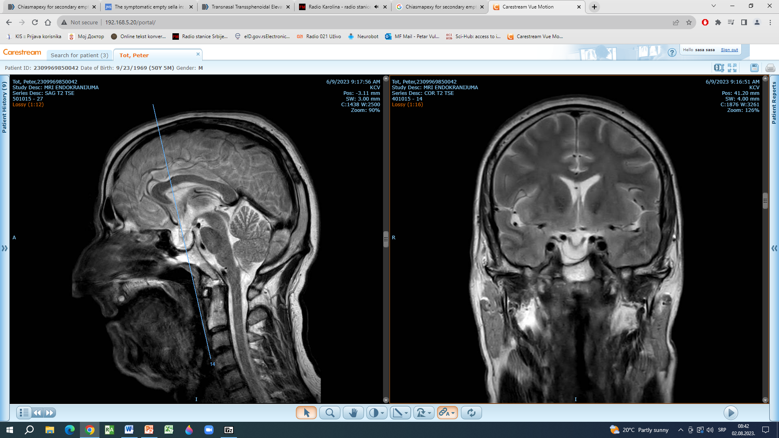

Surgical Procedure
The patient was positioned supine. Under general anesthesia, the patient underwent endoscopic transnasal transsphenoidal surgery providing access to the sphenoid sinus. During the approach, parts of nasal septum bone and cartilage were harvested. A bony opening in the floor of sella turcica was made using a high-speed drill preventing the injury to the dura and CSF leak. Gently dissection followed with mobilization and elevation of the dura of the sellar floor to diminish the displacement of optic nerves, chiasm and tracts. To ensure the extradural fixation of the construction, attainable autologous grafts were used. The cartilage was trimmed to the appropriate size and shape, while the septal bone was shaped to fit the bony defect of the sellar floor. These grafts were precisely tailored to fit and provide support to the repositioned optical system.
Postoperative course was uneventful. On follow-up patient showed improvement of visual impairment (Figure 5,6).

Figure 5. Visual field computerized perimetry prior to surgical treatment
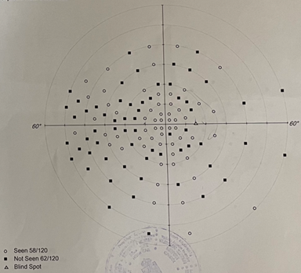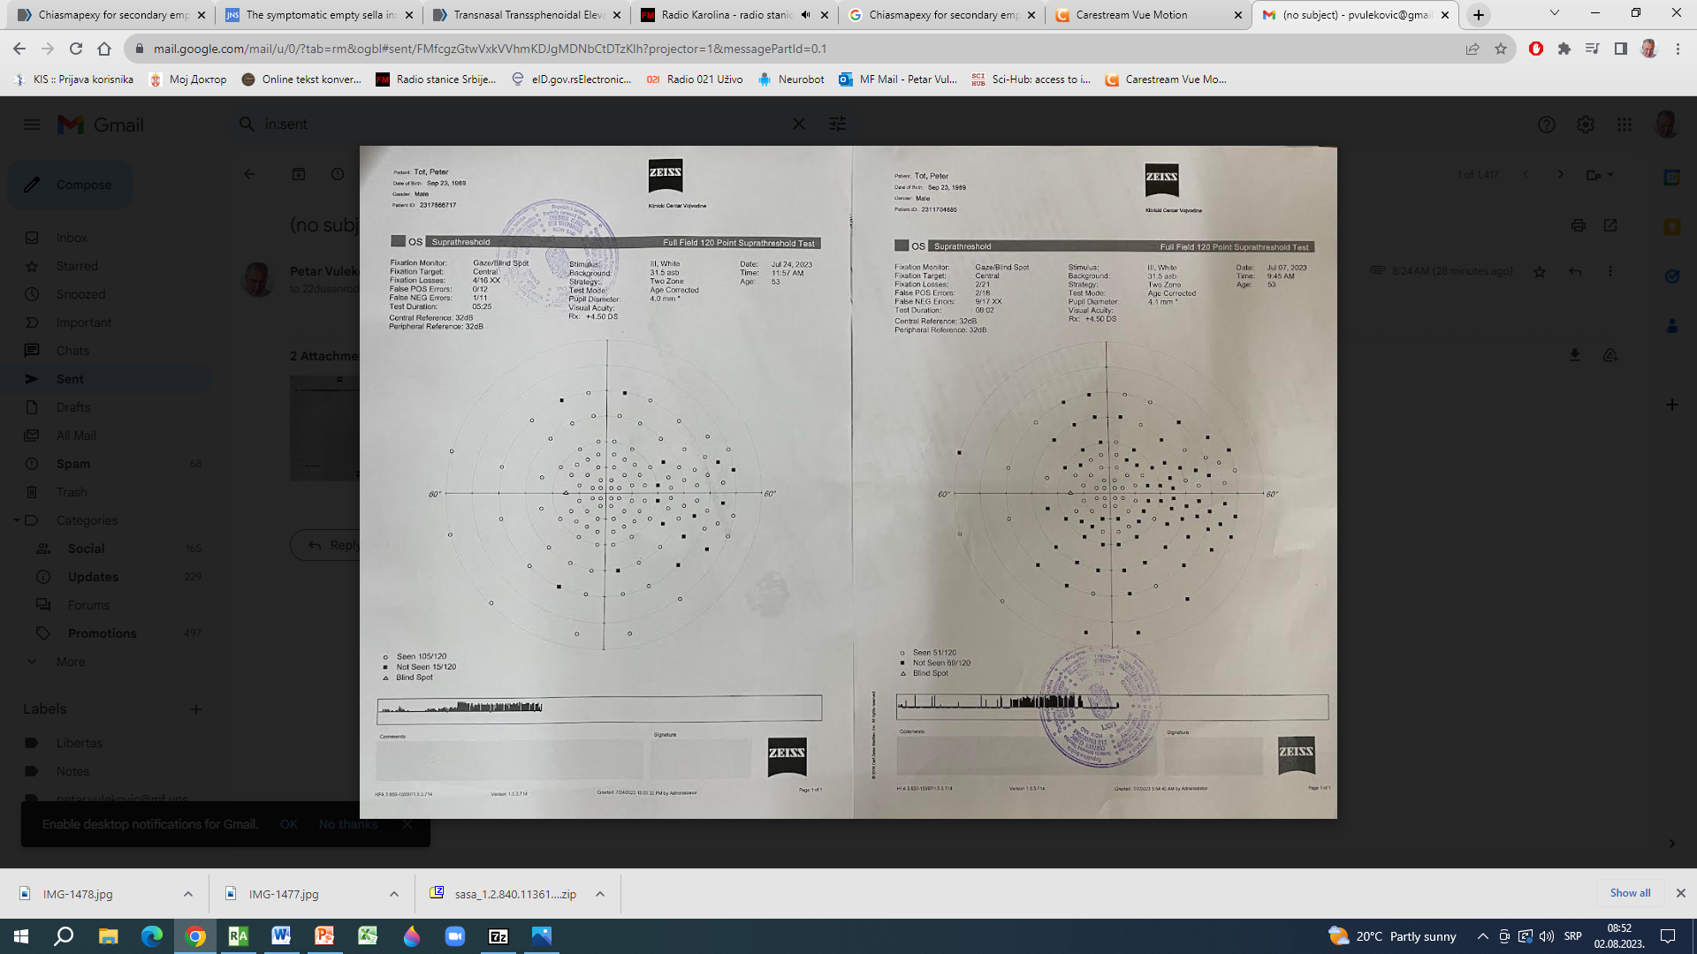
Figure 6. Visual field improvement shown on computerized perimetry after surgical treatment chiasmopexy
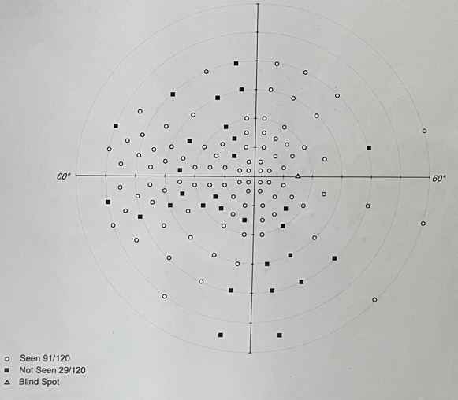

Postoperative MRI image demonstrated a sellar packing with autologous material with optic chiasm elevation with no signs of compression (Figure 7). Hormonal checkup revealed hormonal levels within normal range. No CSF leak or infections were observed during the postoperative period.

Figure 7. Postoperative MRI imaging of sellar region.
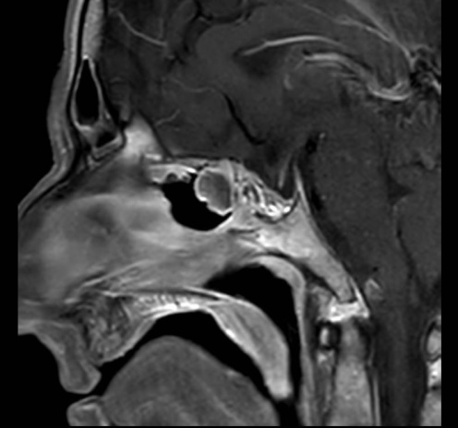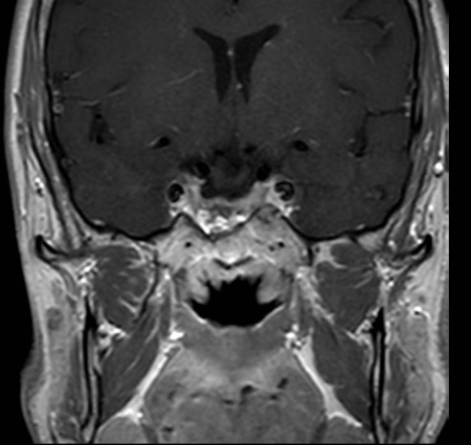

Discussion:Symptomatic SESS after cabergoline treatment for prolactinoma is a rare but challenging complication. The surgical management with chiasmopexy aims to elevate the optic nerves and the chiasm to relieve traction and improve patient symptoms. Over the years, chiasmopexy was performed utilizing different surgical approaches, both intra and extradural, with the use of various materials to stabilize the reposition of the optic system.^{8,9,10} Our case demonstrates successful use of attainable autologous material harvested from the septal bone and cartilage during the endoscopic transnasal transsphenoidal extradural chiasmopexy. The nasal septum provides an easily accessible autologous graft site with suitable biomechanical properties of bone and cartilage for stabilizing the optic chiasm.^{2,3,11,12} Additionally, the autologous material eliminates the risk of graft rejection and reduces the possibility of postoperative complications.^{7,12}

Conclusion:
Endoscopic transnasal transsphenoidal extradural chiasmopexy is an effective surgical procedure in terms of visual field
improvement of patients with symptomatic SESS after medical treatment of pituitary adenoma. The use of easily attainable autologous grafts excludes the need for synthetic materials, reduces the risk of graft rejection additional donor-site surgeries, and postoperative complications.

Disclosures
Funding:
No funding was received for this research.

Conflict of Interest:
All authors certify that they have no affiliations with or involvement in any organization or entity with any financial interest (such as honoraria; educational grants; participation in speakers' bureaus; membership, employment, consultancies, stock ownership, or other equity interest; and expert testimony or patent-licensing arrangements), or non-financial interest (such as personal or professional relationships, affiliations, knowledge or beliefs) in the subject matter or materials discussed in this manuscript.

CORRESPONDENCE
Dušan Rodić, MD
✉ Clinic of Neurosurgery, University Clinical Center of Vojvodina, Novi Sad, Serbia.
Bate Brkića, 2, 21000, Novi Sad, Serbia
☏+381 61 271 2348
@ 22dusanrodic@gmail.com

References:
- Cobb MIH, Crowson M, Mintz-Cole R, Husain AM, Berger M, Jang D, Codd P. Transnasal Transsphenoidal Elevation of Optic Chiasm in Secondary Empty Sella Syndrome Following Prolactinoma Treatment. World Neurosurg. 2018 Apr;112:250-253. doi: 10.1016/j.wneu.2018.01.202. Epub 2018 Feb 6. PMID: 29421446.
- Ishihara E, Toda M, Sasao R, Ozawa H, Saito S, Ogawa K, Yoshida K. Endonasal Chiasmapexy Using Autologous Cartilage/Bone for Empty Sella Syndrome After Cabergoline Therapy for Prolactinoma. World Neurosurg. 2019 Jan;121:145-148. doi: 10.1016/j.wneu.2018.10.012. Epub 2018 Oct 11. PMID: 30315973.
- Barzaghi LR, Donofrio CA, Panni P, Losa M, Mortini P. Treatment of empty sella associated with visual impairment: a systematic review of chiasmapexy techniques. Pituitary. 2018 Feb;21(1):98-106. doi: 10.1007/s11102-017-0842-6. PMID: 29027644.
- Graillon T, Passeri T, Boucekine M, Meyer M, Abritti R, Bernat AL, Labidi M, Dufour H, Froelich S. Chiasmapexy for secondary empty sella syndrome: diagnostic and therapeutic considerations. Pituitary. 2021 Apr;24(2):292-301. doi: 10.1007/s11102-020-01104-5. Epub 2020 Nov 2. PMID: 33136230.
- Olson DR, Guiot G, Derome P (1972) The symptomatic empty sella. Prevention and correction via the transsphenoidal approach. J Neurosurg 37(5):533–537. https://doi.org/10.3171/jns.1972.37.5.0533 - DOI - PubMed
- Welch K, Stears JC (1971) Chiasmapexy for the correction of traction on the optic nerves and chiasm associated with their descent into an empty sella turcica. Case report. J Neurosurg 35(6):760–764. https://doi.org/10.3171/jns.1971.35.6.0760 - DOI - PubMed
- Tsukiyama A, Hattori Y, Tahara S, Ishisaka E, Morimoto D, Oyama K, Teramoto A, Morita A (2017) New technique for chiasmapexy using iliac crest bone graft: 2 cases of visual impairment caused by empty sella syndrome. World Neurosurg. https://doi.org/10.1016/j.wneu.2017.08.080 - DOI - PubMed
- Guiot G, Derome P, Demailly P, Hertzog E (1968) Unexpected complication of complete exeresis of voluminous pituitary adenomas. Rev Neurol 118(2):164–167 – PubMed
- Raverot G, Jacob M, Jouanneau E, Delemer B, Vighetto A, Pugeat M, Borson-Chazot F (2009) Secondary deterioration of visual field during cabergoline treatment for macroprolactinoma. Clin Endocrinol 70(4):588–592. https://doi.org/10.1111/j.1365-2265.2008.03364.x - DOI
- Zona G, Testa V, Sbaffi PF, Spaziante R (2002) Transsphenoidal treatment of empty sella by means of a silastic coil: technical note. Neurosurgery 51(5):1299–1303.
- Guiot G, Derome P (1976) Surgical problems of pituitary adenomas. In: Krayenbuehl H (ed) Neurosurgery. Advances and Technical Standards, vol 3. Springer, Wien, pp 1–33
- Hardy J (1985) Trans-sphenoidal approach to the pituitary gland. In: Wilkins RH, Rengachary SS (eds) Neurosurgery. McGraw-Hill Book Company, New York, pp 889–898

