  - ORIGINAL ARTICLE

Application of the isolated anterior

surgery for the treatment of low-grade isthmic spondylolisthesis
  - Bulatov Aleksandr Vasilyevich¹ Kubetskij Yulij Evgenyevich¹ Rzaev Jamil Afet oglu¹ Amelina Evgeniya Valeryevna² Borisov Norajr Norajrovich³
- Federal Center of Neurosurgery, Novosibirsk, Russia
- Institute of Computational Technologies, SB RAS, Novosibirsk, Russia
- Federal State Budgetary Institution "Novosibirsk Research Institute of Traumatology and Orthopedics named after Ya.L. Tsivyan" of the Ministry of Health of the Russian Federation, Novosibirsk

Abstract
Introduction. Anterior lumbar interbody fusion (ALIF) at the L5-S1 level is a reliable treatment option for degenerative diseases of the spine, but remains controversial for low-grade isthmic L5 spondylolisthesis. The generally accepted methods (gold standard) are PLIF or TLIF (mis vs open) supplemented with transpedicular stabilization [1,2,3,4]. In evaluating the results of surgical treatment, there is no reliable evidence that posterior fusion is superior to ALIF in outcome.
Objective. The study was aimed at evaluation of clinical and radiological outcomes and analysis of the efficacy and safety of stand-alone anterior interbody fusion (ALIF) with simultaneous bone plate fixation in the treatment of low grade isthmic L5 spondylolisthesis, as well as at identification of risk factors for implantfailure and pseudarthrosis development.
Materials and Methods. A retrospective analysis of patients operated on for low-grade isthmic L5 spondylolisthesis (n=196) in the period from 2015 to 2020 was performed. Of these, a separate group of 29 patients operated on using the stand-alone ALIF technique with bone plate fixation was evaluated..
Results. A number of parameters that influenced fusion failure and pseudarthrosis development were identified: the presence of isthmic spondylolisthesis, the preoperative L5 translation volume more than 6 mm, and pelvic incidence (PI)≥60°.
Conclusion. The use of the ALIF technique with bone plate fixation leads to good results when taking into account the parameters of the sagittal balance and the combination of predictive factors of spinal fusion failure.

Keywords:
DOI:

Introduction
The prevalence of isthmic spondylolisthesis in the adult population is 6% [5] with the L5 level involvement in more than 90% of cases [6].
Isthmic spondylolisthesis is a local pathology, but causes disturbance of spinopelvic parameters and results in sagittal imbalance.
Currently, decompression and stabilization operations for low-grade isthmic spondylolisthesis are performed using 5 main techniques: posterior lumbar interbody fusion (PLIF), transforaminal lumbar interbody fusion (TLIF or MIS-TLIF), oblique lumbar interbody fusion (OLIF), anterior lumbar interbody fusion (ALIF), and ALIF in combination with pedicle screw fixation. The generally accepted methods of surgical treatment (gold standards) are PLIF and TLIF supplemented with transpedicular stabilization [1,2,3,4], however no evidence was found that this approach is superior to ALIF in terms of clinical and radiological outcomes.
The ALIF approach has several key advantages: it contributes to the correction of lordosis due to larger implant in terms of surface area, lordotic angle and heightand increased intervertebral foramena [7]; reduces vertebral pain syndrome due to the possibility of avoiding trauma to the back muscles; and alleviates postoperative pain [3,8,9].
Currently, there are a large number of spondylolisthesis classifications based on etiology and on the vertebral body slippage degree. The classification proposed by H.W. Meyerding in 1932 and modified by Junge and Kühl in 1956 [10] is the most common in clinical practice. The SDSG (Spinal Deformity Study Group) classification of spondylolisthesis based on the relationship of spinopelvic parameters s was proposed by H. Labelle et al. in 2011 [11]. The nosological entity of low-grade spondylolisthesis was defined as a translation of one vertebral body over the other by <50% of its anterior-posterior diameter, with three possible types of sagittal profile: 1) balanced, 2) compensated, and 3) imbalanced.
The ALIF procedure without additional fixation can lead to the development of pseudarthrosis due to insufficient primary stability of the implant [8,9]. Fixation provides reliable stabilization of the spine by virtue of a combination of anterior bone fixation plate and a cage [6].
Currently, surgeons have no methods for predicting the risk of developing pseudarthrosis in the treatment of low-grade isthmic spondylolisthesis by the ALIF technique with a plate fixation. Thus, surgeons use transpedicular screw fixation as a preventive measure.
The choice of surgical treatment for low-grade isthmic spondylolisthesis remains a controversial issue. A number of authors suggested that the presence of L5 isthmic spondylolisthesis itself may be a risk factor for failure of anterior stabilization [10]. These considerations and our own experience gave rise to this study.
Objective of the study. The study was aimed at evaluating clinical and radiological treatment outcomes and detrmining the efficacy and safety of anterior lumbar interbody fusion (ALIF) with simultaneous bone plate fixation in the treatment of low grade isthmic L5 spondylolisthesis, as well as at identifying risk factors for the failure of plate fixation and pseudarthrosis development.
Materials and Methods
A retrospective analysis of patients operated on for low-grade L5 isthmic spondylolisthesis was performed. A total of 196 patients were treated from 2015 to 2020. Of these, we evaluated 29 patients with low-grade L5 isthmic spondylolisthesis operated on using the ALIF technique with bone plate fixation. The choice of the surgical treatment technique was based on the clinical manifestations and morphological findings of the compressing substrates of the spinal canal, as well as on the severity of the lumbar sagittal imbalance parameters. ALIF was supplemented with TPF techniques in patients with anatomical difficulties of placing the bone plate (acute S1 angle, low bifurcation of vessels). TPF was also performed in case of fracture of the anterior screws due to pseudarthrosis in the late postoperative period.,
Female patientss prevailed in the study group: 16 (55.2%). The age of the patients averaged 40.3 ± 12.2 years, ranging from 20 to 77 years.
Patient data collection period: January 2015 - December 2020
Inclusion Criteria:
- low-grade isthmic spondylolisthesis (grade 1-3 according to SDSG),
- ALIF with bone plate fixation.
Exclusion Criteria:
- patients with isthmic spondylolisthesis operated on using other techniques.
The patient’s parameters of sex, age, body mass index (BMI), and Charlson Comorbidity Index (CCI) were considered. To assess the severity of pain in the low back (LB) and in legs (LP), a Visual Analogue Scale for pain (VAS-LBP, VAS-LP) was used. The assessment of the degree of functional adaptation was carried out using the Oswestry Disability Index (ODI) [12]. Treatment outcomes were assessed using the MacNab scale [13].
General characteristics of patients including sex, age, BMI, CCI, ODI, and VAS are presented in Table 1.

Criteria | Average/median [1; 3 quartile 1; 3] | Min/max
Age | 40.8/38 [33; 47.2] | 20; 77
BMI | 27.3/27 [23.5; 31.1] | 18.1; 41.0
CCI | 0.83/0.9 [0.77; 0.96] | 0.21; 0.99
ODI | 81.2/80 [78; 84] | 68; 96
VAS LBP | 7.8/8 [6.8; 9] | 3; 10
VAS LP | 6.4/7.5 [5; 9] | 0; 10
Table 1.-General characteristics of patients

Additionally, concomitant diseases, smoking habit, and ethnicity were taken into account, but these factors did not correlate with the treatment outcome and did not show a statistically significant association with the disease outcome (p>0.05). Therefore, these factors were not considered in this study.
The diagnostic protocol of the preoperative examination included history taking, general clinical and neurological examination, questioning, and neuroimaging diagnostics (X-ray, MRI, and spiral CT).
Lumbopelvic relationships were assessed on frontal and sagittal standing plain radiographs of the lumbar spine with the capture of the femoral heads [14]. Sagittal balance parameters were measured using the Sagittal Balance Academy software (www.sagittal-balance.com). Target value of the lumbar lordosis (tLL) was predicted according to the formula: LL=PI × 0.54 + 27.6°; L4-S1= 66% tLL. [10].
Sagittal X-ray of the lumbar spine with functional tests (in the extreme positions of flexion and extension) was performed with preliminary anesthesia to determine spondylolisthesis grade according to the SDSG classification and to identify segmental instability of the spine. Measurement of vertebral body slippage was performed according to the method described by A.A. White and M.M. Panjabi [14] where spinal motion segment was considered unstable at a score 5 or more. The type of lumbar lordosis was determined according to the classification of P. Roussouly (2005) [4] to assess the apex of lordosis and to identify the relationship between the spondylolisthesis development (taking into account the parameters of pelvic modifiers adjusted for age variability) and compensatory mechanisms of sagittal balance [16].
The 1.5T MRI study was performed to clarify the compression of the spinal canal nerve structures, to assess the state of the posterior and anterior longitudinal ligaments and the grade of spinal canal stenosis according to the classification of C. Schizas [17].
The spiral CT study was performed on a multislice computed tomograph (MSCT) with a slice thickness of 64x1.5 mm and subsequent reconstruction in 3D VRT mode. The post-op control scans were taken to assess the degree of the L5 vertebra reduction, the correct position of the implant, and the congruence of the plate fitment.
All patients underwent osteodensitometry in the preoperative period. In the study group, there was no decrease in bone density at the level of surgical intervention (the average age of patients was 40 years). In the vast majority of cases (n=20, 68.9%), osteosclerosis of endplates of adjacent L5 and S1 vertebrae was observed.
The indication for surgical treatment was the presence of persistent spinal pain syndrome (VAS score 5 or more) and (or) radicular syndrome (occurring in an upright position or during physical activity) resistant to conservative treatment for at least 3 months in all 29 patients.
Surgical technique Patients were placed on the table in a 20° reverse Trendelenburg position with knees flexed. An anterior left-sided retroperitoneal approach was performed through a Pfannenstiel incision. The iliac vessels and ureter were mobilized and diluted laterally and upwards. The slipped L5 vertebra was identified. The anterior surface of the L5-S1 disc was exposed. The L5-S1 intervertebral disc was opened and removed up to the posterior longitudinal ligament, which was not opened. The size of the implant was determined by trials. Interbody radiolucent polyethylene ether ketone (PEEK) implants filled with osteoinductive material were used. Pre-lordosed implants with an angle of 8° to 15° were placed. Vertebral body reduction was performed in all cases. Anterior osteophytes were removed, and a platform for installing a fixing plate wasformed. The plate was selected by length and angle of inclination for complete congruence with the surface of the vertebrae. Fixation was performed with 4 screws locked in the plate. Hemostasis and layer-by-layer wound closure were made. The drainage system was not installed in no one case. Operation duration was 134\135 [110;150] minutes, blood loss - 113\60 [50;100] ml.

Evaluation criteria:
- low-grade spondylolysthesis type according to the SDSG classification,
- grade of the L5 vertebra slippage (mm),
- assessment of the type of lumbar lordosis according to the P. Roussouly classification,
-pre-op and post-op sagittal modifiers PI, SS, PT, LL, tLL, SL and LL4-S1 adjusted for age variability [16],
- change in VAS-LBP and VAS-LP scores, ,
- change in quality of life measured by ODI,
- fusion rate and development of pseudarthrosis according to the Bridwell classification [18],
- bone resorption around the screws fixing the plate, or their fracture,
- structure and number of intra- and postoperative complications according to the Dindo-Clavien classification [19].
In all cases, interbody fusion was performed with a pre-lordosed PEEK implant supplemented by bone plate fixation through an anterior approach. The main task of surgical treatment was to restore the anatomical relationship of vertebrae and the parameters of local and segmental sagittal balance. Reduction and fixation of spondylolisthesis, restoring the height of the disc and thereby increasing intervertebral foramina were performed by placing a pre-lordosed implant. The choice of the lordotic angle of implant was determined by the degree of sagittal imbalance at the L4-S1 level and by the deficit of target lordosis (tLL).

Statistical processing.
Data presentation format was mean/median [1st; 3rd quartile]. Data processing was carried out using R software version 3.5.3 [20]. To compare pre- and postoperative parameters, a two-tailed Wilcoxon test was used, the comparison of the parameters of 2 independent groups was carried out using a two-tailed Mann-Whitney test. The estimate of confidence intervals for the degree of LL correction was based on the Bootstrap approach [21].
Results.
All patients in the preoperative period had vertebrogenic pain syndrome with VAS score of 6 to 9. Segmental instability at the level of spondylolisthesis (the White-Panjabi score of 5 or more) was clinically manifested only by spinal pain syndrome (VAS score of more than 5) in 13 (44.8%) patients. In 16 (55.2%) cases, there was a combination of spinal pain syndrome with radicular syndrome. Pain in the leg in all cases was due to foraminal stenosis, which was confirmed by neuroimaging data. In the study cohort, 7 (24.1%) patients had SDSG type 2 spondylolisthesis,, and 22 (75.9%) - type 3. The distribution of patients to H.W. Meyerding classification was as follows: 17 (58.6%) patients with grade I spondylolisthesis, and 12 (41.4%) patients – with grade II.
Prior to surgery, the degree the L5 slippage varied from 5 to 13 mm. In the group of patients with Meyerding grade I, the slippage ranged from 5 to 9 mm, in the group of patients with grade II - from 6 to 13 mm.
Control points: the result was evaluated in the early postoperative period within 14 days after surgery (control point 1), after 3 months (control point 2) and after 12 months (control point 3).
Immediate result.
In the study group of patients, there was no increase in neurological deficit and complications in the surgical site. In the postoperative period, all patients achieved the planned correction angle of segmental and local lordosis and a statistically significant decrease in VAS-LBP and VAS-LP score. Parameters of sagittal modifiers (SL, LL4-S1) were corrected in accordance to individual target indicators in all cases.
Long-term result. The long-term result was followed-up from 12 to 72 months after surgery. Based on X-ray data, 3 groups of patients were identified.
Group 1 included 15 patients (51.7%) with complete solid fusion of grade I according to the Bridwell scale [18], maintenance of corrected sagittal balance parameters, and regression of spinal pain syndrome (Fig. 1).

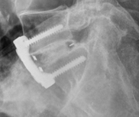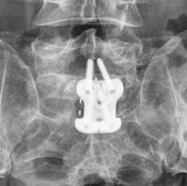
Fig 1. Postoperative X-ray and CT control 6 months after surgery

Group 2 included 5 patients (17.2%) with fractures of the lower screws locking the bone plate, fusion of grade I-II according to the Bridwell scale, and regression of spinal pain syndrome (Fig. 2).

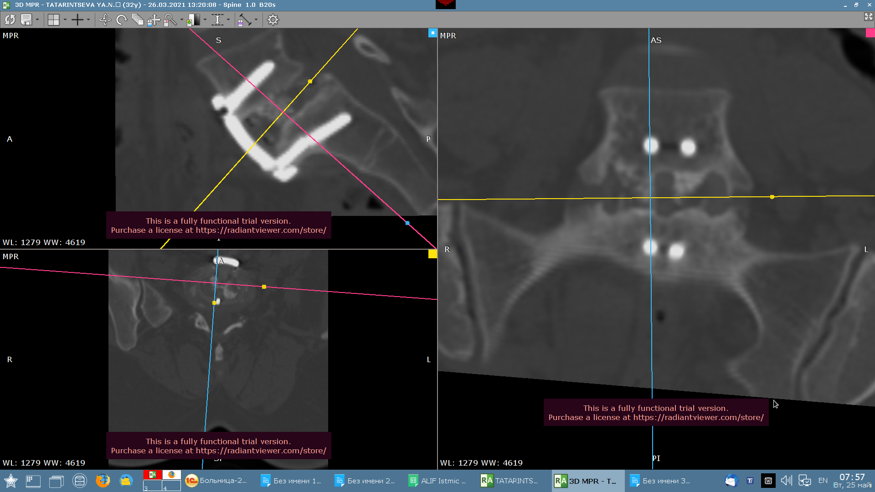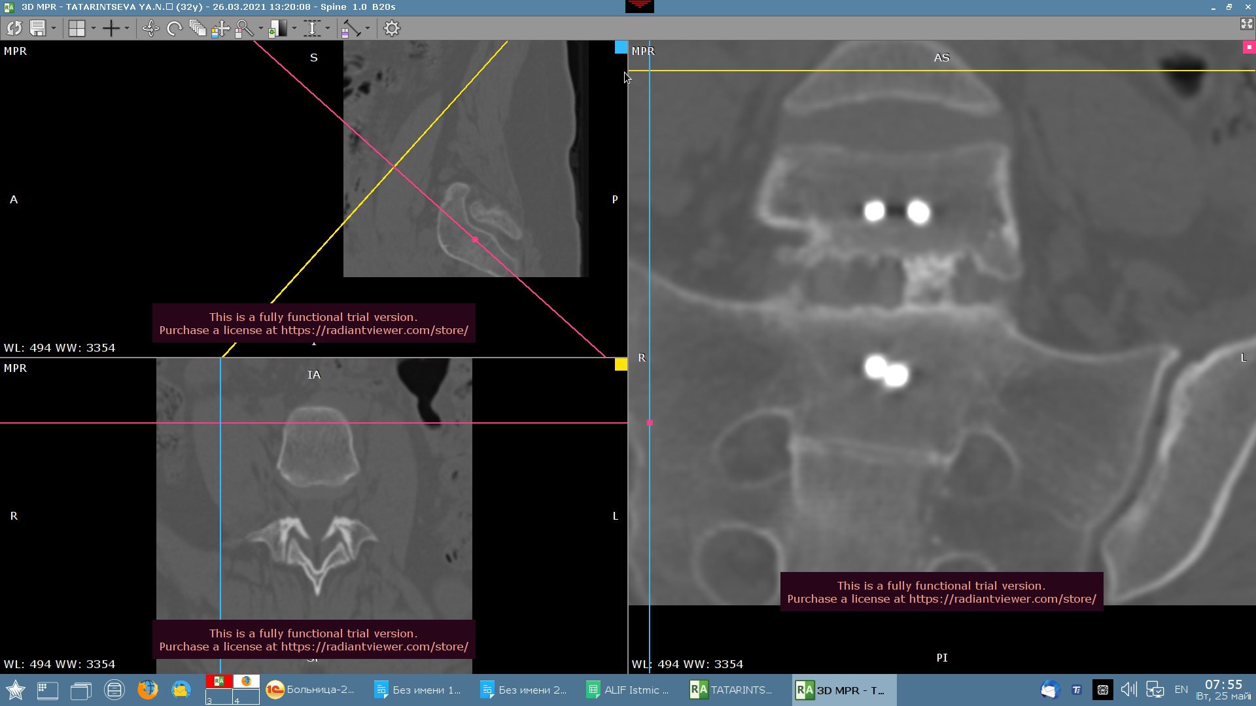
Fig.2.
A – fracture of the lower screws locking the fbone plate,
B – the formed bone block with an ingrow through the interbody implant

Group 3 included 9 patients (31.1%) with failure of metal fixation (fracture of the lower screws locking the bone plate and the development of pseudarthrosis), fusion of grade III-IV according to the Bridwell scale, and persistent spinal pain syndrome. This group of patients underwent a reoperation 7 to 11 months after the primary one, including MIS transpedicular fixation at the L5-S1 level fresulting in the regression of spinaln syndrome (Fig. 3).

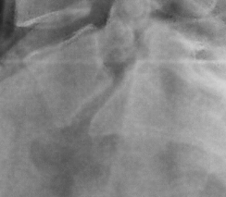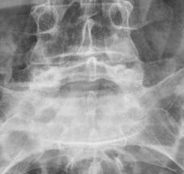
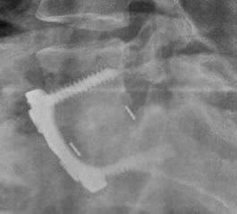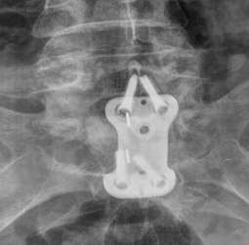
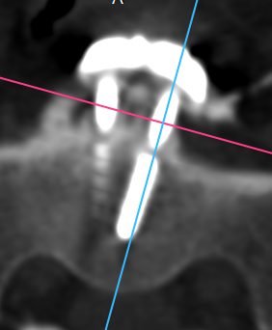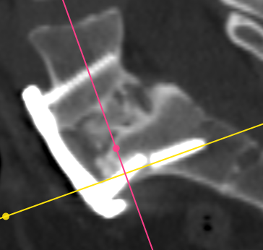
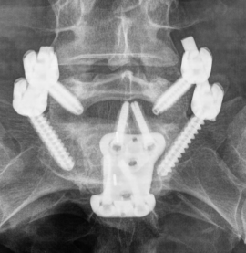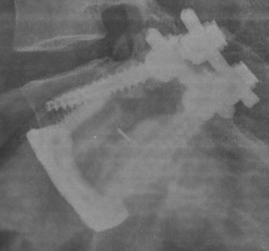
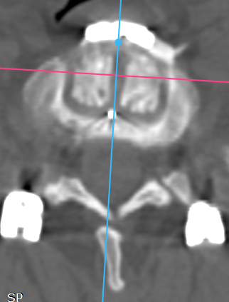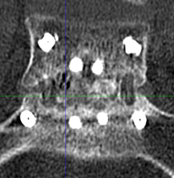
Fig.3.
A - Preoperative X-ray in 2 planes,
B – X-ray control after 3 months,
C - MSCT control after 6 months: fracture of the lower screws locking the bone plate,
D – X-ray control after additional stabilization with the MIS transpedicular system,
E - MSCT control of the formed bone block with ingrows through the interbody implant

Sagittal balance parameters
Table 2.- Sagittal balance parameters in dynamics

All balance parameters in dynamics are summarized for groups in Table 2.

 | L4-S1 |  | LL | PT | SL | SS
Before surgery
Group 1 | 40.7/42.5 [34; 50.8] |  | 62.7/63 [53.5; 73.2] | 16.1/15 [14; 17.8] | 12.5/14 [6.5; 18.2] | 45.5/44.5 [39.2; 51.2]
Group 2 | 40.6/40 [37; 42] |  | 63.2/63 [58; 71] | 15.2/13 [12; 16] | 10.6/12 [6; 14] | 47/50 [36; 51]
Group 3 | 40.1/36 [32; 48] |  | 63.8/67 [54; 73] | 17.3/17 [9; 20] | 11.9/11 [6; 15] | 45.3/45 [38; 55]
Upon discharge
Group 1 | 44.9/43.5 [36.2; 47.2] |  | 57.1/52 [49.2; 59] | 19.5/16.5 [14.2; 26.8] | 21.1/19 [12.8; 21.8] | 44.3/40 [34.5; 47]
Group 2 | 41.2/44 [33; 49] |  | 55.4/54 [44; 55] | 13.4/12 [11; 14] | 14/13 [11; 18] | 45.4/48 [34; 53]
Group 3 | 39.4/40 [34; 40] |  | 47.6/50 [40; 53]* | 16.1/17 [14; 17] | 18.8/17 [12; 22]* | 40.2/41 [35; 42]
Follow up
Group 3 | 43.8/40 [35.5; 44.5] |  | 64.4/59.5 [55.2; 77] | 18.4/16.5 [14.2; 20.5] | 20.3/17.5 [14.2; 21.2]* | 47/45.5 [37.2; 54.8]
2nd group | 39.4/40 [33; 45] |  | 61/63 [52; 68] | 22.6/24 [17; 24] | 11.4/12 [7; 16] | 50.6/53 [50; 56]
3rd group | 44.1/40 [36; 51] |  | 58.6/55 [50; 60] | 20.9/19 [17; 26] | 14/14 [13; 17] | 44/41 [39; 49]
Follow up upon revision
3rd group | 41.7/44 [35; 48] |  | 58.2/57 [50; 67] | 23/19 [15; 31] | 13.4/13 [12; 17] | 44.2/48 [40; 51]

Fig. 4 presents PI values for different groups indicated by dots. It can be seen that groups 2 and 3 are characterized by a fairly high PI value (60 or more).

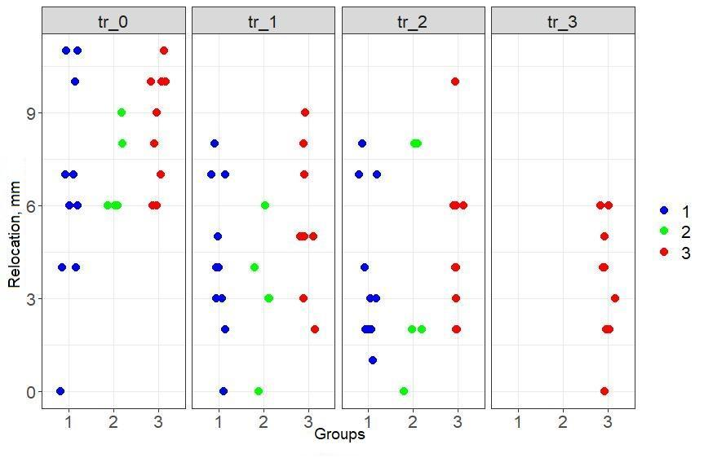
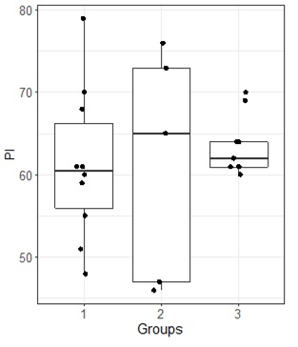
Fig. 5 shows the distribution of L5 slippage. It should be noted that in groups 2 and 3, all patients had a slippage of 6 mm or more.

Fig 4.

Fig 5.

We have tried to generalize the above-mentioned analysis and build a logistic regression model. Its parameters are shown below (Table 3).

 | Coefficient | р | OR | CI
Model’s free term | -0,117 | 0,598
 | 0,701 | 0,006 | 2,017 | [1.284; 3.168]
LL irregularities after surgery | -0,012 | 0,090 | 0,989 | [0.976; 1.001]
Table 3.- A logit- regression model.

Quality characteristics of the regression model: AUC = 0.85, sensitivity = 0.86, specificity = 0.70, with a threshold value of 0.626.
The resulting odds ratios (OR) characterize the risks as follows:
The main correction of the parameters of the sagittal modifiers and the VAS (LBP, LP) and ODI questionnaires is presented in Table 4. The final values ​​of the questionnaires (both VAS and ODI) did not have a statistically significant difference for the considered groups, i.e. “an equally good clinical result was achieved".

 | VAS LBP |  | VAS LP | ODI
Before surgery
Group 1 | 7.5/8 [6.2; 9] |  | 6.8/8 [5.5; 9] | 80.6/82 [78; 84]
Group 2 | 7.8/8 [6; 10] |  | 4.2/2 [1; 8] | 80.8/78 [76; 86]
Group 3 | 8/8 [8; 8] |  | 7.1/7 [5; 8] | 82.2/80 [80; 82]
Upon discharge
Group 1 | 4.9/4.5 [4; 6]* |  | 3.8/4 [3; 5]* | 60.4/62 [50; 69]*
Group 2 | 4.8/5 [2; 7] |  | 3.8/4 [1; 6] | 68.6/70 [70; 76]
Group 3 | 6.2/6 [5; 7] |  | 5.7/6 [5; 6] | 67.4/64 [64; 74]*
Follow up
Group 3 | 5.4/5 [4; 8]* |  | 4.4/4 [3; 5]* | 58.2/58 [54; 66]*
Follow up upon revision
3 group | 3.7/3 [3; 5]* |  | 2.3/3 [1; 3]* | 35/33 [28; 40]*
Table 4.-Saggital parameter dynamics based on VAS and ODI scores.

Dynamics of sagittal profile parameters and VAS and ODI scores
* p<0.05 when compared with preoperative value
There was a statistically significant decrease in VAS (LBP) and ODI scores in all groups. When evaluating the results of surgical treatment on the MacNab scale, good and excellent results were obtained in 68.9% of cases after the stand-alone ALIF surgery. Сombination of ALIF and MIS transpedicular fixation techniques (in Group 3) provided good and excellent results in 86.2% of cases.
Complications.
Complications were assessed according to the Dindo-Clavien classification [19]. In 2 cases, the peritoneum was intraoperatively damaged followed by its simultaneous suturing (grade I according to the Dindo-Clavien classification). These patients had previously undergone abdominal surgery. In the early postoperative period, there were no increase in neurological deficit and complications in the surgical site. Also, the occurrence of dynamic intestinal paresis was not noted in any case.
Discussion.
Isthmic spondylolisthesis is a pathology of the spine that can lead to disruption of the normal spatial relationships between the spine and the pelvis, to a greater extent than others.
In isthmic spondylolisthesis, the increase in the lumbar lordosis allows maintaining sagittal balance. In other words, hyperlordosis of the lumbar spine in isthmic spondylolisthesis is a compensatory mechanism that develops in response to anterior slippage of the vertebra. Hyperlordosis is the first of three compensatory mechanisms that may be engaged in patients with isthmic spondylolisthesis. Shear and compression forces affect the L5-S1 intervertebral disc. Shear forces in L5-S1 isthmic spondylolisthesis tend to disrupt the natural formation of the bone block [4]. In our study, the degree of reduction had a statistically insignificant effect on the development of pseudarthrosis and instrumentation failure.
Surgical treatment of isthmic spondylolisthesis remains a controversial issue. Lumbar interbody fusion can be performed posteriorly (PLIF) [1,2,3], through transforaminal approach (MIS TLIF) [22,23], anterior approach (ALIF) [2,8,9,22], or combined approach in one stage (anterior + posterior) [21]. From a biomechanical point of view, ALIF is considered more effective than PLIF or TLIF [2,3]. Currently, surgeons do not have methods for predicting the risk of plate fixation failure and of pseudarthrosis development after the ALIF-only technique at L5–S1, which would require planning an adjuvant posterior stage of surgery. Some authors have suggested that the presence of L5 isthmic spondylolisthesis may be a risk factor for plate fixation failure [24]. Thus, given the lack of a systematic literature review confirming the effectiveness of the stand-alone ALIF use for this pathology, it is difficult to determine the ideal surgical tactics for isthmic spondylolisthesis in adults.
The ALIF approach has several key advantages: it allows a direct view of the disc space along the midline and extensive lateral exposure of the vertebral bodies, which allows for efficient discectomy and endplate preparation [8]. The anterior approach makes it possible to install implants with the maximum height and surface area of f​​usion, which contributes to the correction of lordosis and restoration of the foraminal height [7]. The anterior approach to the lumbar spine protects the posterior dorsi and anterolateral psoas muscles, which can reduce postoperative pain, disability, and the occurrence of adjacent segment disease [8]. However, stand-alone ALIF procedure without additional fixation is a non-rigid method of bone block formation, which in some cases can lead to pseudarthrosis or plate fixation failure [8,9].
Tai et al. [23] in a comparative cohort study of degenerative spinal pathology showed that ALIF leads to greater recovery of segmental lordosis, disc height, and a better clinical outcome, as compared with TLIF.
A. Jaeger et al. [25] reported on the isolated use of the ALIF technique with plate fixation at the L5-S1 level. According to them, ALIF technique is more reliable for the treatment of degenerative spinal pathology than of isthmic spondylolisthesis. The development of pseudoarthrosis in degenerative pathology of the spine was 4.5%, and in isthmic spondylolisthesis it reached 50% (p <0.001).
Statistically, pseudarthrosis in isthmic spondylolisthesis occurs in patients with high preoperative LL, SS and PI, which corresponds to Roussouly type 4 [4]. The presented data correlate with the results of our study. However, in the study by A. Jaeger et al., the degree of the L5 vertebral body slippage was not taken into account. According to our data, the vertebral body slippage of more than 6 mm before surgery is also one of the predictors of the failure of stand-alone ALIF with plate fixation (p <0.001).
In fact, most patients with isthmic spondylolisthesis have high PI and SS with a horizontal sacrum and a vertical sacral endplate that forms a triangular L5–S1 intervertebral space. In this situation, shear forces increase dramatically, which explains the increased risk of fixation failure and pseudarthrosis, even with the additional use of a plate.
Despite the risk of fusion failure, the use of ALIF remains a relevant surgical method to reduce sagittal imbalance, especially in patients with high PI who need LL correction [22].
The anterior approach is criticized because of the high risk of severe intraoperative complications [2,4,10], but their frequency varies enormously between series, from 0.42 [10] to 17% [4]. The risk of intraoperative complications is reduced with careful selection of patients (BMI, history of operations through the anterior abdominal wall, individual anatomical features of the location of vessels) and taking into account the learning curve of the operating team.
Conclusions
While the retrospective design and a limited patient sample pose as study limitations, which may affect the generalizability of the findings, ALIF technique is associated with positive outcomes in patients with low-grade isthmic spondylolisthesis, with optimal sagittal balance parameters and excluded predictors of fusion failure. Notably, SDSG type 3, preoperative L5 vertebra slippage exceeding 6 mm, and pelvic inclination of 60° or more were linked to an increased risk of implant fracture and pseudarthrosis .
Future studies with larger patient cohorts and extended follow-up periods are needed to validate our findings and further explore the relationship between these parameters and long-term surgical outcomes.

Disclosures
Study Design: retrospective non-randomized monocentric cohort outcome-controlled study. The level of evidence: 2c (outcome studies, UK Oxford, version 2009).
Study Base: Spinal Department of the Federal Center of Neurosurgery (Novosibirsk)
Ethical Approval: The study was approved by the ethics committee of the Federal Center of Neurosurgery, Novosibirsk.

CORRESPONDENCE
Aleksandr V. Bulatov
✉
☏0000-0001-8019-6047
@bulatov-av@mail.ru

References

- Ohtori S, Koshi T, Yamashita M, Takaso M, Yamauchi K, Inoue G, et al: Single-level instrumented posterolateral fusion versus non-instrumented anterior interbody fusion for lumbar spondylolisthesis: a prospective study with a 2-year follow-up. J Orthop Sci Off J Jpn Orthop Assoc 16:352–358, 2011.
- Wang SJ, Han YC, Liu XM, et al. Fusion techniques for adult isthmic spondylolisthesis: a systematic review. Arch Orthop Trauma Surg. 2014;134(6):777–784. https://doi.org/10. 1007/s00402-014-1985-9.
- Noorian S, Sorensen K, Cho W: A systematic review of clinical outcomes in surgical treatment of adult isthmic spondylolisthesis. Spine J 18:1441–1454, 2018.
- Roussouly P. Classification of the normal variation in the sagittal alignment of the human lumbar spine and pelvis in the standing position / P. Roussouly, S. Gollogly, E. Berthonnaud // Spine. – 2005. – Vol. 30, N. 3. – P. 346–353.
- Kreiner S., Baisden J., Daniel J Mazanec , Rakesh D Patel , Robert S Bess Guideline summary review: an evidence-based clinical guideline for the diagnosis and treatment of adult isthmic spondylolisthesis. Spine J. 2016 Dec;16(12):1478-1485. doi: 10.1016/j.spinee.2016.08.034.
- Bozkus H, Chamberlain RH, Perez Garza LE, Crawford NR, Dickman CA. Biomechanical comparaison of anterolateral plate, lateral plate, pedicule screws-rods for enhancing anterolateral interbody cage stabilisation. Spine 2004;29:635—41.
- Cho W, Sokolowski MJ, Mehbod AA, et al. MRI measurement of neuroforaminal dimension at the index and supradjacent levels after anterior lumbar interbody fusion: a prospective study. Clin Orthop Surg. 2013;5(1):49–54. doi.org/10.4055/cios.2013.5.1.49.
- Kim JS, Choi WG, Lee SH: Minimally invasive anterior lumbar interbody fusion followed by percutaneous pedicle screw fixation for isthmic spondylolisthesis: minimum 5-year follow-up. Spine J 10:404–409, 2010.
- Allain J, Delecrin J, Beaurain J, Poignard A, Vila T, Flouzat-Lachaniette CH: Stand-alone ALIF with integrated intracorporeal anchoring plates in the treatment of degenerative lumbar disc disease: a prospective study on 65 cases. Eur Spine J 23:2136–2143, 2014.
- Junge, H. /Bruns. Beitr. Klin. Chir. – 1956. – Vol. 193, N 1. – P. 39–58. Appearance And Significance Of Neural Symptoms In Lumbar Spondylolisthesis And Indications For Operative Management.
- Labelle H. /Eur Spine J (2011) 20 (Suppl 5):S641–S646 Spino-Pelvic Sagittal Balance Of Spondylolisthesis: A Review And Classification.
- Fairbank JC, Couper J, Davies JB, O’Brien JP.The Oswestry low back pain disability questionnaire. Physiotherapy. 1980;66:271–273.
- Macnab I. A. N. Negative disc exploration //J Bone Joint Surg Am. – 1971. – Т. 53. – №. 5. – С. 891-903.
- White A.A., Panjabi M.M.(Eds.), Clinical biomechanics of the spine, 2nd ed, JB Lippincott, Philadelphia, PA, 1990.
- Le Huec J.C., Hasegawa K. Normative values for the spine shape parameters using 3D standing analysis from a database of 268 asymptomatic Caucasian and Japanese subjects // Eur. Spine J. 2016. Vol. 25, No 11. P. 3630-3637. DOI: 10.1007/s00586-016-4485-5.
- Does One Size Fit All? Defining Spinopelvic Alignment Thresholds Based on Age: Conference: NASS 29th Annual Meeting / F.J. Schwab, B. Liabaud, B.G. Diebo, J.S. Smith, R.A. Hostin, C.I. Shaffrey, O. Boachie-Adjei, C.P. Ames, B. Douglas, S. Bess, M. Gupta, T.S. Protopsaltis, V. Lafage, ISSG // Spine J. 2014. Vol. 14, No 11. P. S120-S121. DOI: 10.1016/j.spinee.2014.08.299
- Schizas C, Theumann N, Burn A, et al. Qualitative grading of severity of lumbar spinal stenosis based on the morphology of the dural sac on magnetic resonance images. Spine (Phila Pa 1976) 2010;35(21):1919–1924.
- Bridwell K.H., Lenke L.G., McEnery K.W. et al. Anterior structural allografts in the thoracic and lumbar spine // Spine. – 1995. – Vol.20. – P.14101418.
- Validatinga therapy-oriented complication grading system in lumbar spine surgery: a prospective population-based study/D.Bellut,J.K.Burkhardt, D. Schultze, H.J. Ginsberg, L. Regli, J. Sarnthein // Sci. Rep. 2017. Vol. 7, No 1. P. 11752. DOI: 10.1038/s41598-017-12038-7.
- R Core Team (2019) R: A Language and Environment for Statistical Computing. R Foundation for Statistical Computing, Vienna, Austria. https://www.R-project.org/
- Efron B., Tibshirani R. An Introduction to the Bootstrap. Chapman & Hall/CRC. 1993.
- Phan K, Thayaparan GK, Mobbs RJ. Anterior lumbar interbody fusion versus transforaminal lumbar interbody fusion - systematic review and meta-analysis. Br J Neurosurg 2015;29:705-11.
- Tye EY, Tanenbaum JE, Alonso AS, Xiao R, Steinmetz MP, Mroz TE, et al: Circumferential fusion: a comparative analysis between anterior lumbar interbody fusion with posterior pedicle screw fixation and transforaminal lumbar interbody fusion for L5-S1 isthmic spondylolisthesis. Spine J 18:464–471, 2018.
- Jabłońska-Sudoł K., Maciejczak A. Relationship between the spino-pelvic parameters and the slip grade in isthmic spondylolisthesis. n e u r o l o g i a i n e u r o c h i r u r g i a p o l s k a 4 9 ( 2 0 1 5 ) 3 8 1 – 3 8 8.
- Jaeger A, Giber D, Bastard C, Thiebaut B, Roubineau F, Flouzat Lachaniette CH, Dubory A. Risk factors of instrumentation failure and pseudarthrosis after stand-alone L5-S1 anterior lumbar interbody fusion: a retrospective cohort study. J Neurosurg Spine. 2019 May 31;31(3):338-346. doi: 10.3171/2019.3.SPINE181476. PMID: 31151106.

