Usage of Gentamicin and Vancomycin versus Normal Saline lavage intraoperatively to treat infected depressed skull fractures in traumatic brain injury patients
  - Tahreem Fatima¹, Umar Nadeem², Aleeha Batool³, Shahzad Shams⁴
1-4 Department of Neurosurgery, Mayo Hospital, Lahore, Pakistan.

Abstract
Background: Traumatic Brain Injury often results in Depressed Skull Fractures (DSF), leading to significant morbidity and mortality. Preventing postoperative infections is crucial in managing DSF cases effectively.
Materials and Methods: A Prospective Case-Control Study involving 62 DSF patients undergoing surgical intervention was conducted over six months. Data on demographics, intraoperative details, complications, and outcomes were collected and statistically analyzed using SPSS version 28.
Results: The gentamicin-vancomycin lavage group exhibited a notable reduction in hospital stays (mean: 4.32 days vs. 15.81 days for saline, p < 0.001) and higher Glasgow Outcome Scale (GOS) scores (mean: 4.81 vs. 3.26 for saline, p < 0.001). Complications, including CSF leaks (25% vs. 40.3% for saline) and infections (8.1% vs. 11.3% for saline), were lower in the gentamicin-vancomycin lavage cohort. Reintervention rates were significantly lower in the gentamicin-vancomycin lavage group as well (4.3% vs. 24.2% for saline, p = 0.001).
Conclusions: Intraoperative gentamicin and vancomycin lavage significantly reduced complications, hospital stays, and improved outcomes in DSF cases. This suggests the potential for localized antibiotic interventions to become standard in managing DSF-associated morbidity.
Keywords:
DOI:

INTRODUCTION
Traumatic brain injury (TBI) due to head trauma is a common presentation in emergency departments. In the United States, around 1.7 million people suffer TBI with older adolescents (ages 15 to 19 years) and older adults (ages 65 years and older) among the most likely to sustain a TBI. [1] TBI can be associated with injuries involving the skull as well as brain parenchyma. Based on the pattern, skull fractures can be classified into linear, depressed, and comminuted fractures. A skull fracture is called depressed when any portion of the fracture line's outer table lies below the inner table's normal anatomic position. [2] Depressed skull fracture (DSF) typically occurs when objects with a large amount of kinetic energy make contact with the skull over a fairly small area. [3] Depressed skull fractures can often be diagnosed on routine skull radiography but computed tomographic scan brain non-contrast especially bone window is the gold standard diagnostic method. [4] The incidence of DSF has been reported to be 6% in all head injuries and 11% in severe head injuries. DSF can be managed conservatively in some cases but in most cases, it prompts surgical intervention especially when DSF are compound fractures and have dural tears which have shown a prominent association with cranial infections. The overall incidence of infection following depressed skull fractures has been reported to be 10.6% and has been associated with a higher incidence of persistent neurologic deficit, late-onset epilepsy, and death. [5] A National study reported dural tears, free bone fragments, and late presentations (more than 8 hours after trauma) as important risk factors in postoperative infectious complications. [6] Timely surgical intervention if needed is one of the main factors advocating the decrease in the risk of infection in depressed skull fractures. This is evident in the study by Jannett et al which reported 5% infection incidence in early and 37% infection incidence in late surgery. [7] Antibiotics have also been linked with decreased infection rates in patients with depressed skull fractures. The use of post-operative antibiotics has been adapted for a long time and often includes a 7 to 14-day course of intravenous metronidazole, ceftriaxone, and vancomycin, followed by a 10-day course of oral ciprofloxacin.[8] In contaminated wounds with depressed skull fractures, intraoperative saline wash is often recommended to decontaminate site, [9] however local instillation or application of antibiotics such as gentamicin and vancomycin has shown some promising evidence in infection prevention. [10,11,12,13] The two methods have never been compared. In our set up the current standard of care is intra-operative normal saline wash. Our study compared the use of a dual wash (containing gentamicin and vancomycin) with normal saline wash in order to evaluate the risk of post operative infection rates and overall cost-effectiveness of the two methods.

MATERIALS AND METHODS
A Prospective Case Control Study was conducted in the Neurosurgery Department, Emergency Complex, Mayo Hospital, Lahore for a duration of 6 months; from 01-01-2022 to 30-06-2022. Stratified Random Sampling was used and the total sample size was 62 cases i.e. 31 patients in both case and control groups. The patients who were included in the study were patients who suffered from depressed skull fractures due to head trauma, who had dirty wounds on presentation, who underwent surgical intervention, who underwent redo intervention, & patients with ages between 6 to 55 years. The patients who were excluded from the study were patients who had co-morbidities like CKD, CLD, and CHF, patients with linear skull fracture due to head trauma, patients who underwent conservative management for depressed skull fractures, patients who had coagulation defects, patients who did not give consent to join the study & patients at the extremities of ages i.e. less than 6 years and more than 55 years. Patients with linear skull fractures and those managed conservatively would not be eligible for the intervention under study and were thus excluded. Furthermore, comorbidities and extremes of age would affect prognosis independently and were excluded to avoid any confounding variables on the overall post-operative prognosis and infection rates. For this study, the intervention under study was intraoperative lavage. In the case group, a mixture of gentamicin and vancomycin was used whereas, in the control group, normal saline was used. The lavage was done in each case before Duraplasty/primary dura repair, after Duraplasty/primary dura repair, and after skin closure. A dressing soaked in respective reagents was also placed on the wound post-operatively which was removed after 24 hours. The patients in both groups were discharged on systemic antibiotics including Ceftriaxone 1g twice daily, Amoxicillin/Clavulanic Acid 1.2g twice daily, and Metronidazole 400mg twice daily. A structured Performa highlighting demographics, clinical findings, intra-operative findings, and interventions, as well as complications and outcomes of the patients in regards to the case and control groups, was used to collect data along with consent from the participant in the regional language after proper disclosures. The data was analyzed using the latest version of the statistical package for social science SPSS version 28. It has been represented using different tables and charts. Different statistical tests like independent sample t-test, and chi-square test were used to assess the significance of different variables with respect to the case and control groups.

RESULTS

Pre-operative variables
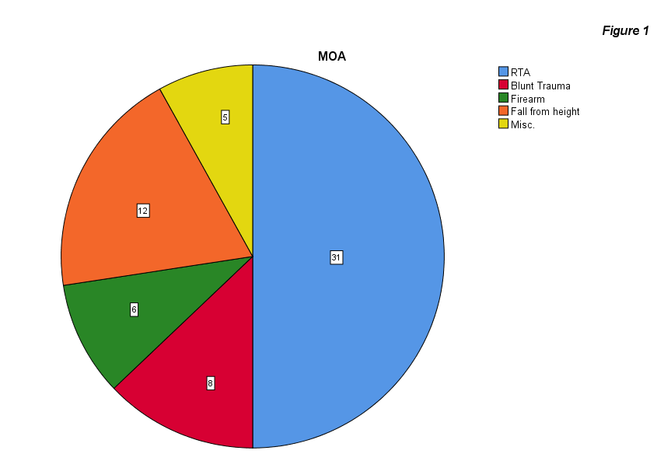
The mean age of participants of our study group was 25.85 ± 13.28 years with the minimum age of the participant being 7 years and the maximum age of the participant being 51 years. Among them, 61.3% (n=38) of the participants were male while the rest of the participants were female (38.7%, n=24). The most common mechanism of injury was Road Traffic Accident (50%, n=31) followed by fall from height (19.4%, n=12) and blunt trauma to head (12.9%, n=8) which has been described in Figure 1.

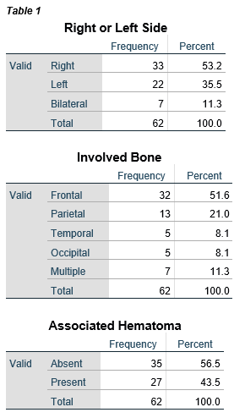

The status of patient on presentation was assessed using the Glasgow Coma Scale (GCS). The mean GCS at presentation was 12.74 ± 2.579 with the minimum GCS recorded at presentation to be 5 while the maximum GCS recorded at presentation was 15. The CT-Scan Findings at presentation showed predominantly right sided (53.2%, n=33) frontal depressed bone fractures (51.6%, n=32) without any associated hematoma (56.5%, n=35). It has been explained in detail in Table 1.
Moreover, at presentation, most of the patients had an open wound (77.4%, n=48) with CSF leak (51.6%, n=32) without any foreign body (71%, n=44) or brain matter (61.3%, n=38) visible on inspection. Refer to Table 2.
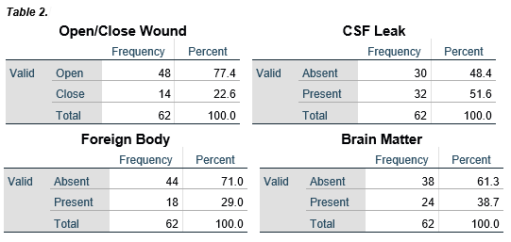

Intra-operative Variables
In a majority of the cases, multiple bony chips were noted intra-operatively (58.1%, n=36) while a minority had a single bony chip (41.9%, n=26). Similarly, there was a breach in dura matter detected intra-operatively in a majority of cases (56.5%, n=35). In 43.5% of the cases (n=27) intra-operative hematoma was noted while it was absent in the majority of the cases. (56.5%, n=35).

Surgical interventions
The primary intervention comprised of multiple options included bone elevation, bony chips removal, hemostasis, and primary Duraplasty. Bone elevation was done in 71% cases (n=44), removal of bony chips was done in 59.7% of the cases (n=37), there was a need for hemostasis in 45.2% of the cases (n=28), and primary Duraplasty was done in 37.1% of the cases (n=23).

Outcome Variables
The overall mean duration of hospital stay in our study was 10.06 ± 11.712 days with a minimum stay of 2 days and a maximum stay of 56 days. In the control group (normal saline wash), the mean duration of hospital stay was 15.81 ± 14.284 days whereas in the case group (gentamicin and vancomycin wash), the mean duration of hospital stay was 4.32 ± 2.60. The independent sample t-test showed a statistical difference (p < 0.001) in hospital stay between the case and control groups. Furthermore, the overall mean GOS in our study was 4.03 ± 1.318 with a minimum GOS of 1 (death) and a maximum GOS of 5 (complete recovery). In the control group (normal saline wash), the mean GOS was 3.26 ± 1.413 whereas in the case group (gentamicin and vancomycin wash), the mean GOS was 4.81 ± 0.543. The independent sample t-test also showed a statistical difference (p < 0.001) in GOS between the case and control groups. Moreover, Pearson Correlation test showed a negative correlation between the duration of hospital stay and GOS. (Pearson’s correlation co-efficient= -0.799, p < 0.001).
In most of the cases, the south Hampton grade of the wound 7 days after the last surgical intervention was 0 depicting normal healing (56.4%, n=35) followed by Grade III depicting clear or sero-sanginous discharge (24.2%, n=15). The rest of the grades of wound (I, II, IV & V) have similar presentation (4.8%, n=3). The respective South Hampton Grade of the wound 7 days after the last surgical intervention in the case and control groups are depicted in Figure 2.

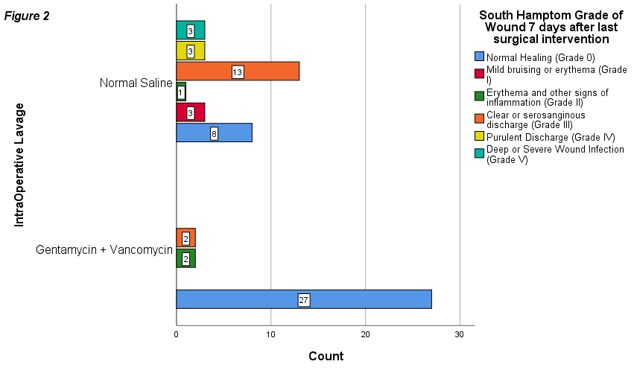

Post-operative Complications

Among the postoperative complications, post-operative CSF leak/discharge due to flap necrosis was the most common (40.3%, n=25), followed by post-operative meningitis (12.9%, n=8), post-operative osteomyelitis / sub-galeal abscess (11.3%, n=7) and post-operative cerebral abscess (8.1%, n=7). The respective presentation of these postoperative complications in the case and control groups is mentioned in Table 3.
There was a need for re-intervention after the primary intervention in only 4.3% cases (n=3) in the case group as compared to 24.2% cases (n=15) in the control group. The chi-square test of independence shows a statistical significance (p=0.001) between the case and control groups when a comparison is made regarding the need for re-intervention after the primary intervention. A similar statistical significance is shown by the chi-square test of independence when the case and control groups are compared with regard to the need for repeat Duraplasty (p=0.015). The individual difference in different interventions done after the primary intervention in the case and control groups is shown in Figure 3.

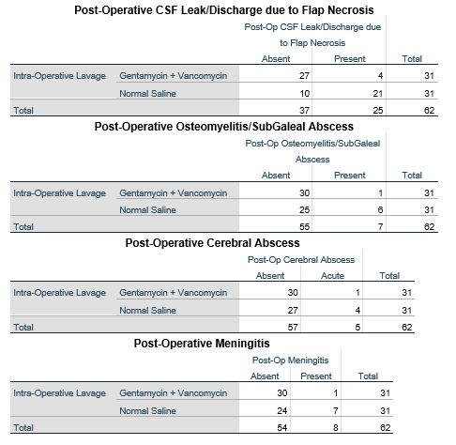
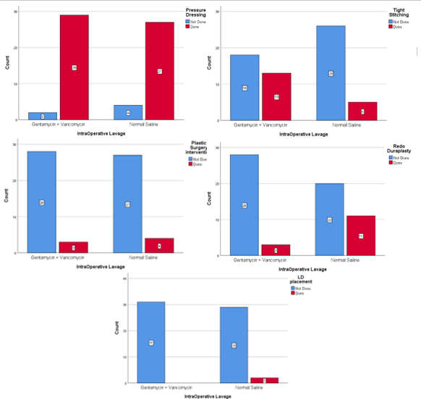

DISCUSSION
The massive disease burden of TBI in Pakistan can be attributed to social, political and economic factors. An inefficient healthcare infrastructure with delays in timely referral and neurosurgical intervention compound the problem and increase overall morbidity and mortality related to TBI. A report issued in 2022 proclaimed that nearly 800,000 people suffer from TBI in Pakistan every year, out of which nearly 60,000 to 70,000 people suffer from significant morbidity and mortality. [14] Even in developed countries TBI leads to an estimated loss of $30 billion annually. [15] Our study aimed to compare two standard decontamination methods used in neurosurgical interventions on depressed skull fractures, in order to determine which technique provided reduced post-operative morbidity and mortality and hence, in theory, overall cost effectiveness to decrease disease burden on the health-sector.

Pre-operative and intra-operative variables
The mean age of the patients was found to be 25.85 i.e. in the third decade of their lives with a male to female ratio of 1.6:1. A similar study conducted in Pakistan by Rehman, L. also reported the mean age of the patients to be in the third decade of their lives with a male to female ratio of 4.6:1. There is a clear male preponderance and the most common mode of injury is road traffic accidents followed by falls and blunt trauma to the head. This may be due to cultural norms in the country allowing easier access to vehicles for males. Our results for both variables are similar to previous studies done in the region. [16,17] Another contributing factor here could be difference in bony architecture of the skull in both males and females that predisposes males to depressed skull fractures. [18] An institutional study conducted in India, a country bordering Pakistan with similar cultural norms, over a period of six years also reported RTA to be the most common mechanism of injury. [19] The same study reported the most common site of injury to be the frontal region corresponding to our findings. This is further supported by a study conducted in Pakistan by Ahmed, S. et. al. Both these studies also reported predominant absence of associated hematomas in accordance with our findings, however these studies individually documented the incidence of EDH, SDH and contusions which our study did not. [19, 20]
The mean GCS of the patients at the presentation was 12.74 ± 2.579 in our study which is higher compared to a study conducted in Khyber Pakhtunkhwa (another province in Pakistan) in 2021 which reported the mean GCS of patients at presentation to be 10.64 ± 2.33. [21] This difference can be attributed to disparity in infrastructure between provinces and the quicker transit times in our setting. Most of the depressed skull fractures in our study were open fractures (56.5%) which is similar to the results reported by Ahmed, S. et. al (77.7%). However our study reported increased incidence of dural tears (56.5%) which was in contrast to this study which reported incidence at 48.9% [20] . Our study also reported higher incidence of CSF leakage pre-operatively(51.6%) which in stark contrast to the 5.2% reported in another study carried out in Pakistan. Our study had a smaller sampling size which might be the cause of this discrepancy. [22]

Surgical interventions
The primary intervention was bone elevation along with the removal of bony chips which is the surgical method of choice, especially when involving compound fractures. [23] The predominance of open fractures and multiple bony chips explains the high percentages of bone elevation and removal of bony chips reported in our study. The high percentages of dural tears and CSF leaks at presentation in our study are responsible for primary Duraplasty in approximately 37% of the cases in addition to primary dura repairs.
All neurosurgical interventions on infected depressed skull fractures involve the use of systemic antibiotics to reduce the risk of infections. [16,23] In our study, we used intra-operative antibiotics for lavage in the case group to study the relevant effect on the outcome variables as compared to the control group in which a normal saline lavage was used. The use of an antibiotic intra-operative lavage is superior to a non-antibiotic lavage in the prevention of surgical site and intra-cavity infections. [24] Gentamicin is a common antibiotic used for lavage which provides a broad gram negative cover and is often used as a valuable added therapy in gram negative infections which are often not responsive to intravenous antibiotics. [25] Similarly, Vancomycin is a potent antibiotic useful against even the resistant strains of gram-positive bacteria which are a prevalent cause of surgical site infections. [26]
This rationale for local instillation of antibiotics to reduce post-operative infections has also been supported by Uysal, E. et. al in their study that used subgaleal vancomycin powder.[11] In our context of inefficient sterilization practices, increased patient load, and poor personal and hospital hygiene has led to an endemic of highly resistant strains of MRSA in our local settings. [27] Knowing this prevalence of MRSA it would have compromised patient care and the ethical standards of our study to have used Gentamicin alone. Therefore, the use of Vancomycin was essential in our hospital setting.

Outcome variables and Post-operative Complications
Our study showed a significant statistical reduction in postoperative complications including CSF leak or discharge due to flap necrosis, postoperative infection leading to osteomyelitis, sub-galeal abscess, cerebral abscess, and meningitis with the use of gentamicin and vancomycin lavage intra-operatively. Moreover, a significant reduction in redo operations was also noted in the case group. There was also a significant difference in the duration of hospital stay and GOS between the case and control groups. However, there are some confounding factors that often prolong the hospital stay of the patient in our setting including low GDP per capita, unavailability of rehabilitation centers, the prevalence of ventilator-associated infections, and poor personal and hospital hygiene which often results in superimposed hospital-associated infections ultimately affecting the GOS. It is likely that a proportion of the overall morbidity and mortality is also associated with these confounding variables present in our setting.
There are currently no studies comparing normal saline lavage to antibiotic lavage available. Uysal, E. et. al gave promising evidence towards local instillation of antibiotics to reduce post-operative infection rates in depressed skull fractures. [11] Another research on the paediatric population conducted in Cairo on infections rates after primary placement of bone chips in depressed skull fractures reported lower rates of infection after cleaning fragments with betadine, saline and gentamicin. [13] The statistically significant difference in the outcome variables between the case and control groups in our study as well as these two studies warrants further deliberation.
The usage of intraoperative gentamicin and vancomycin lavage is has the potential to reduce morbidity associated with TBI in highly burdened trauma settings of developing countries with inadequate surgical sterilization protocols and patient related parameters. The long term cost effectiveness of this still needs to be evaluated and longer follow up studies with larger sampling size are needed to develop protocols to possibly mandate its use in depressed skull fractures.

CONCLUSION
Depressed skull fractures (DSFS) are a major economic concern due to their morbidity and mortality. This study compared intra-operative gentamicin and vancomycin wash (case group) with normal saline wash (control group) in interventions on DSFs and showed a significant decrease in duration of hospital stay and better GOS in the case group. There was also a decreased incidence of post-operative complications including CSF leakage, flap necrosis, osteomyelitis, subgaleal abscess, cerebral abscess meningitis and repeat surgical interventions in the case group. This study provides promising evidence to encourage research towards local instillation of antibiotics during surgical interventions.

Disclosures
Conflict of Interest: All authors certify that they have no affiliations with or involvement in any organization or entity with any financial interest (such as honoraria; educational grants; participation in speakers' bureaus; membership, employment, consultancies, stock ownership, or other equity interest; and expert testimony or patent-licensing arrangements), or non-financial interest (such as personal or professional relationships, affiliations, knowledge or beliefs) in the subject matter or materials discussed in this manuscript.
Ethical approval: All procedures performed in studies involving human participants were in accordance with the ethical standards of the institutional and/or national research committee and with the 1964 Helsinki declaration and its later amendments or comparable ethical standards.
Informed consent: Informed consent was obtained from all individual participants included in the study.
Funding: No funding was received for this research.

Acknowledgement
The first author would like to thank Professor Laligam Sekhar, his great teacher and friend, former Director of the World Skull Base Association, and Professor Rudolf Fahlbusch for his guidance, helpful suggestions and the review of this article, drawings and charts.

Correspondence
✉︎
☏
@

References
- Hussein, A. A., Laeke, T., & Yohannes, D. (2022). Clinical Outcomes and Prognostic Determinants of Surgically Treated Depressed Skull Fracture in Addis Ababa University Neurosurgical Teaching Hospitals: A Prospective Multicenter Observational Study. World Neurosurgery, 158, e55-e63. https://doi.org/10.1016/j.wneu.2021.10.089
- Kelly, Adrian Kelly & Lekgwara, Patrick. (2018). Evaluating patient epidemiology and clinical practice on the outcome of patients admitted with skull fractures secondary to assault. Clinical Practice. 10.4172/clinical-practice.1000436.
- Manoz-Sanchez MA, Murillo-Cabezas F, Cayuela-Dominguez A, Rincón-Ferrari MD, Amaya-Villar R, León-Carrión J. Skull fracture, with or without clinical signs, in mTBI, is an independent risk marker for neurosurgical relevant intracranial lesion: a cohort study. Brain Inj.2009;23:39.
- Salia, S. M., Mersha, H. B., Aklilu, A. T., Baleh, A. S., & Lund-Johansen, M. (2018). Predicting Dural Tear in Compound Depressed Skull Fractures: A Prospective Multicenter Correlational Study. World Neurosurgery, 114, e833-e839. https://doi.org/10.1016/j.wneu.2018.03.095
- Irshad M, Manzoor CA, Aamir M. The frequency of infection in early versus late surgery of compound depressed skull fractures in adults. International Surgery Journal. 2018;5(2):538. doi:10.18203/2349-2902.isj20180347
- Jennett B, Miller J. Infection after depressed fracture of the skull. Implications for management of nonmissile injuries. J Neurosurg. 1972;36:333-9.
- Zapata, L., Wright, E. J., & Nakaji, P. (2018). Clinical and Neurosurgical Management of Cranial Machete Injuries: The Experience of a Tertiary Referral Center in Nicaragua. World Neurosurgery, 116, 140-143. https://doi.org/10.1016/j.wneu.2018.05.020
- Anehosur, V., Sahana, M. S., & Kumar, N. (2022). Grossly Depressed Frontal Bone Fracture in a Paediatric Patient: A Case Report. Journal of maxillofacial and oral surgery, 21(2), 442–446. https://doi.org/10.1007/s12663-020-01456-2
- Kolodziejczyk, D., & Hirsch, W. D. (1992). Epidurale "Sulmycin Implant"-Abdeckung zur lokathe len Infektionsprophylaxe bei der operativen Versorgung offener Schädel-Hirn-Verletzungen [Epidural "sulmycin implant" coverage for local prevention of infection in surgical management of open craniocerebral injuries]. Aktuelle Traumatologie, 22(6), 272–275.
- Uysal, E., Çal, M. A., & Cine, H. Advance 2). The use of vancomycin powder in the compound depressed skull fractures. Clinical neurology and neurosurgery, 225, 107570. Advance online publication. https://doi.org/10.1016/j.clineuro.2022.107570
- Sekhar V, Ramprasad KV, Kavita K. Open skull fractures with brain fungation: Simple principles for good outcome-Our experience. International Archives of Integrated Medicine. 2015 Sep 1;2(9).
- WAEL M. NAZIM, M.D., A. K. M. Infection Rate in Pediatric Compound Depressed Fractures Following Primary Replacement of Bone Fragments. The Medical Journal of Cairo University, 2021; 89(March): 419-422. doi: 10.21608/mjcu.2021.153960
- Correspondent; The Express Tribune (May 22,2022) ‘‘800,000 suffer head injuries every year in Pakistan’, The Express Tribune; URL: https://tribune.com.pk/story/2357713/800000-suffer-head-injuries-every-year-in-pakistan
- Hoyt DB, Holcomb J, Abraham E, Atkins J, Sopko G: Working Group on Trauma Research Program Summary Report: National Heart Lung Blood Institute (NHLBI), National Institute of General Medical Sciences (NIGMS), and National Institute of Neurological Disorders and Stroke (NINDS) of the National Institutes of Health (NIH), and the Department of Defense (DOD). J Trauma 57:410–415, 2004
- Rehman, L., Ghani, E., Hussain, A., Shah, A., Noman, M. A., & Khaleeq-Uz-Zaman (2007). Infection in compound depressed fracture of the skull. Journal of the College of Physicians and Surgeons--Pakistan : JCPSP, 17(3), 140–143.
- Asif, M., & Fatima, A. (2017). Depressed Skull Fracture Management of 100 Cases at DHQ Teaching Hospital/Sahiwal Medical College Sahiwal. Pakistan Journal Of Neurological Surgery, 21(3), 144-148.
- Yavuz, M. Sunay MD; Asirdizer, Mahmut MD; Cetin, Gursel MD; Günay Balci, Yasemin MD; Altinkok, Muzaffer MD. The Correlation Between Skull Fractures and Intracranial Lesions Due To Traffic Accidents. The American Journal of Forensic Medicine and Pathology 24(4):p 339-345, December 2003. | DOI: 10.1097/01.paf.0000103011.14578.c3
- Manne S, Musali SR, Gollapudi PR, Nandigama PK, Mohammed I, Butkuri N, et al. Surgical outcomes in depressed skull fractures: An institutional experience. Asian J Neurosurg 2019;14:815-20.
- Ahmad, S., Afzal, A., Rehman, L., & Javed, F. (2018). Impact of depressed skull fracture surgery on outcome of head injury patients. Pakistan journal of medical sciences, 34(1), 130–134. https://doi.org/10.12669/pjms.341.13184
- Tariq, M., Mian, M. A., Filza, F., Ayub, S., Khan, S. D., & Jalal, K. (2021). Outcome of patients operated for depressed skull fracture with dural tear. Pakistan Journal Of Neurological Surgery, 25(2), 126-133.
- Junaid M, Nabi A, Khan MA, Umair M. Prevalence of cerebrospinal fluid leak in traumatic head injury at a Tertiary Care Center. Journal of Islamabad Medical & Dental College. 2019 Sep 29;8(3):123-6.
- Bullock, M. R., Chesnut, R., Ghajar, J., Gordon, D., Hartl, R., Newell, D. W., Servadei, F., Walters, B. C., Wilberger, J., & Surgical Management of Traumatic Brain Injury Author Group (2006). Surgical management of depressed cranial fractures. Neurosurgery, 58(3 Suppl), S56–iv. https://doi.org/10.1227/01.NEU.0000210367.14043.0E
- Norman, G., Atkinson, R. A., Smith, T. A., Rowlands, C., Rithalia, A. D., Crosbie, E. J., & Dumville, J. C. (2017). Intracavity lavage and wound irrigation for prevention of surgical site infection. The Cochrane database of systematic reviews, 10(10), CD012234. https://doi.org/10.1002/14651858.CD012234.pub2
- Toms, J., Kurczewski, L., Simonds, R., Graham, R. S., & Harrison, J. (2019). Gram-negative Cranial Bone Flap Infection Treated with Continuous Gentamicin Irrigation: A Case Report. Cureus, 11(3), e4282. https://doi.org/10.7759/cureus.4282
- Kourbeti, I. S., Vakis, A. F., Papadakis, J. A., Karabetsos, D. A., Bertsias, G., Filippou, M., Ioannou, A., Neophytou, C., Anastasaki, M., & Samonis, G. (2012). Infections in traumatic brain injury patients. Clinical microbiology and infection : the official publication of the European Society of Clinical Microbiology and Infectious Diseases, 18(4), 359–364. https://doi.org/10.1111/j.1469-0691.2011.03625.
- Syed, M. A., Jamil, B., Ramadan, H., Rukan, M., Ali, S., Abbasi, S. A., Woodley, T. A., & Jackson, C. R. (2021). Genetic Diversity of Staphylococcus aureus Strains from a Tertiary Care Hospital in Rawalpindi, Pakistan. Microorganisms, 9(11), 2301. https://doi.org/10.3390/microorganisms9112301

